<https://www.youtube.com/watch?v=g9c66TUylZ4&list=PLblh5JKOoLUICTaGLRoHQDuF_7q2GfuJF&index=40>



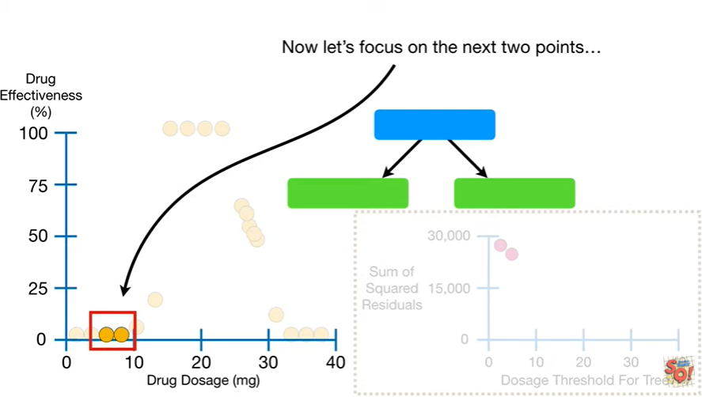

Now let's focus on the next two points

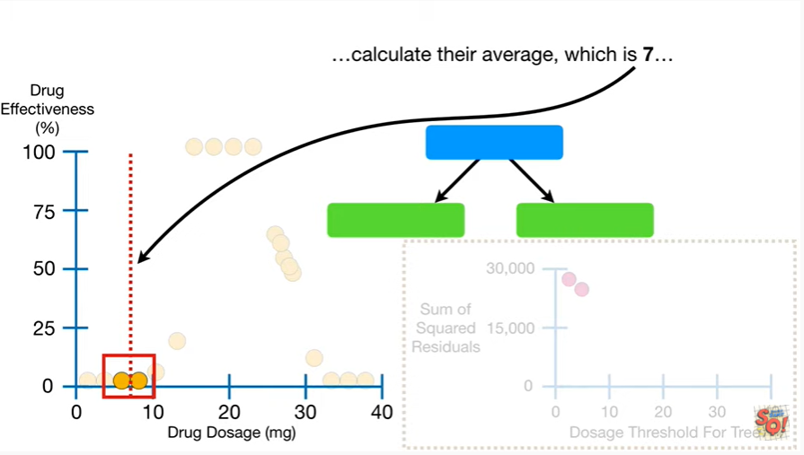

calculate their average which is seven

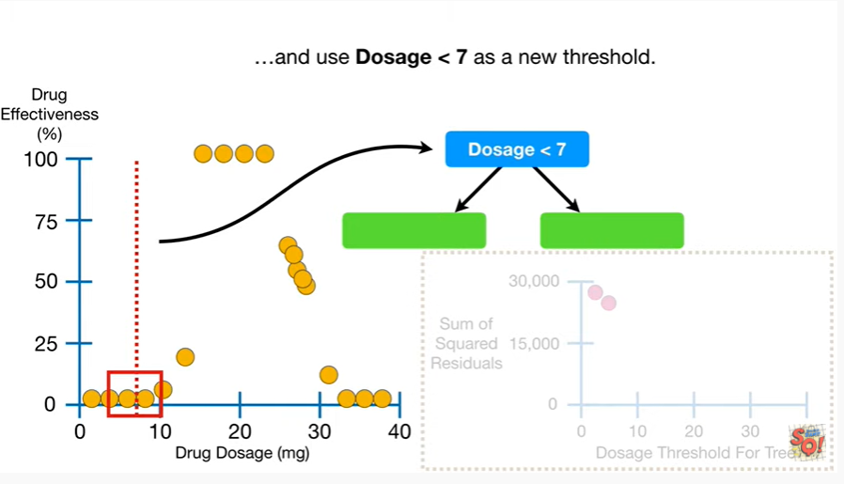

and use dosage less than seven as a new threshold.

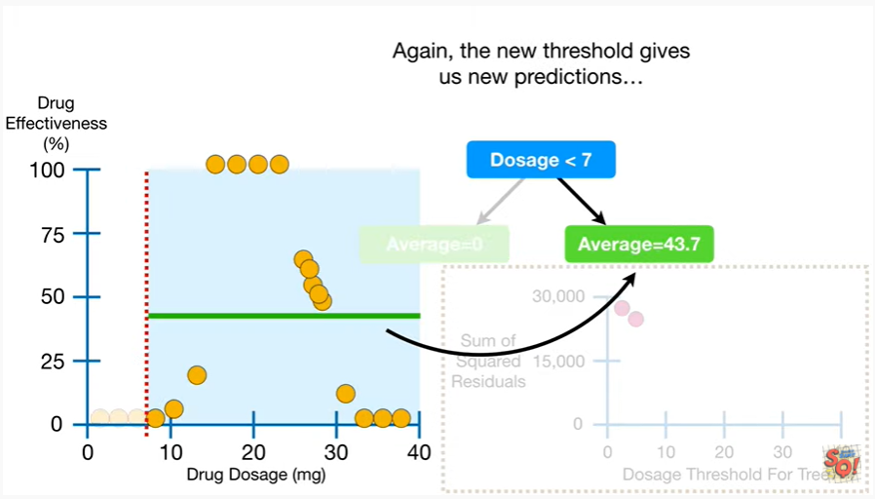

Again the new threshold gives us new predictions

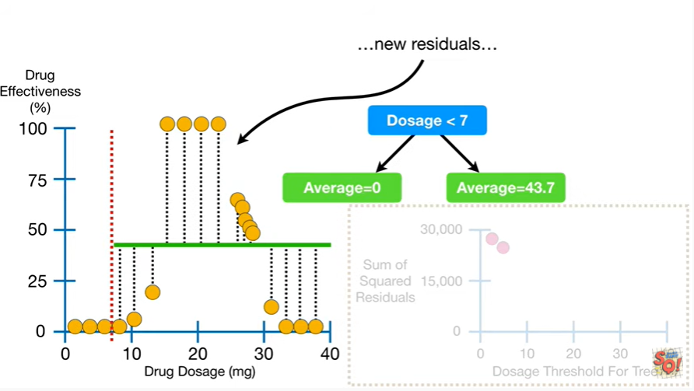

new residuals

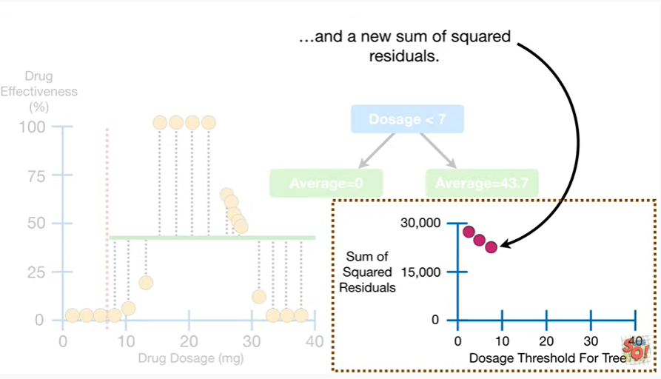

and a new sum of squared residuals.

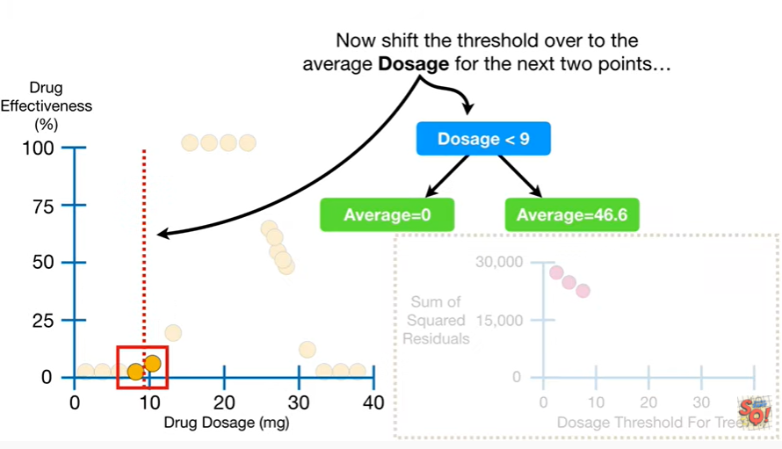

Now shift the threshold over to the average dosage for the next two points

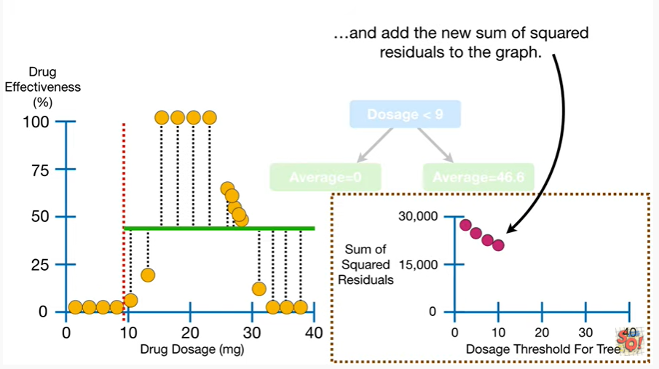

and add a new sum of squared residuals to the graph.

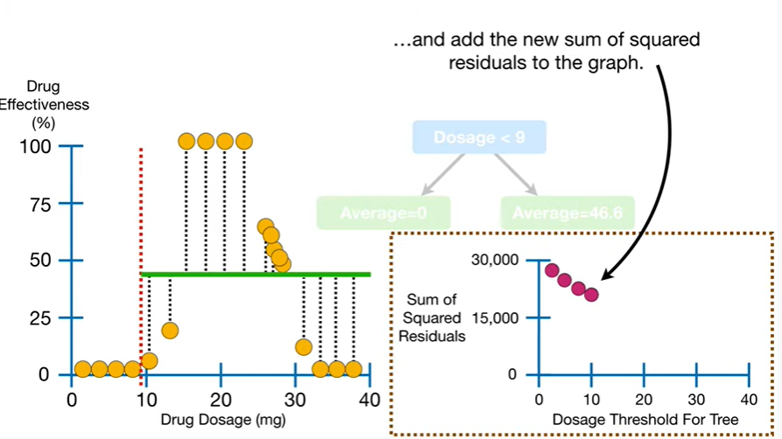

And we repeat until we have calculated the sum of squared residuals for all of the remaining thresholds.

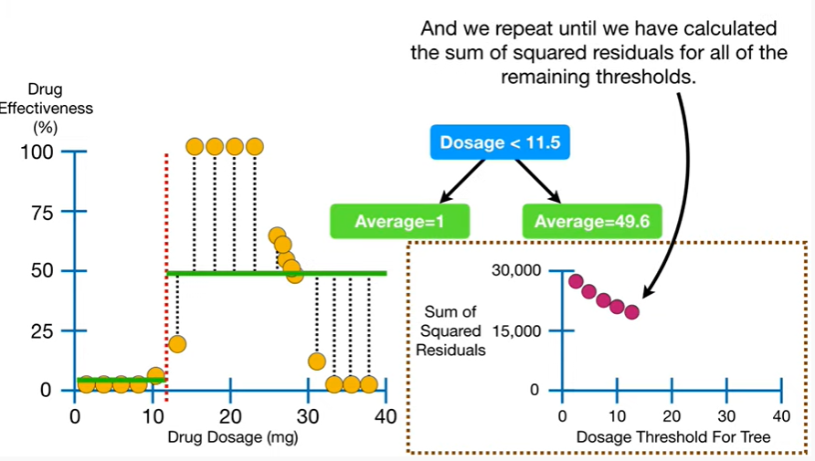

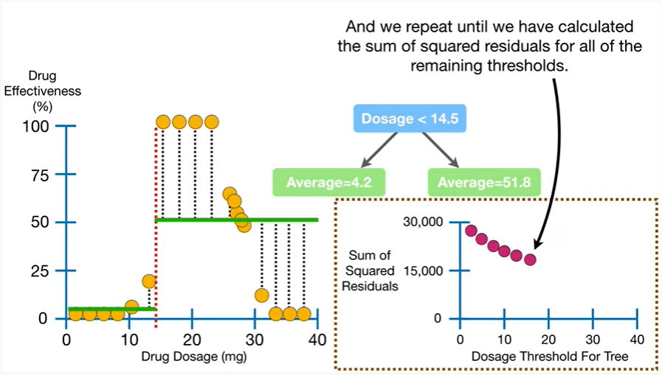

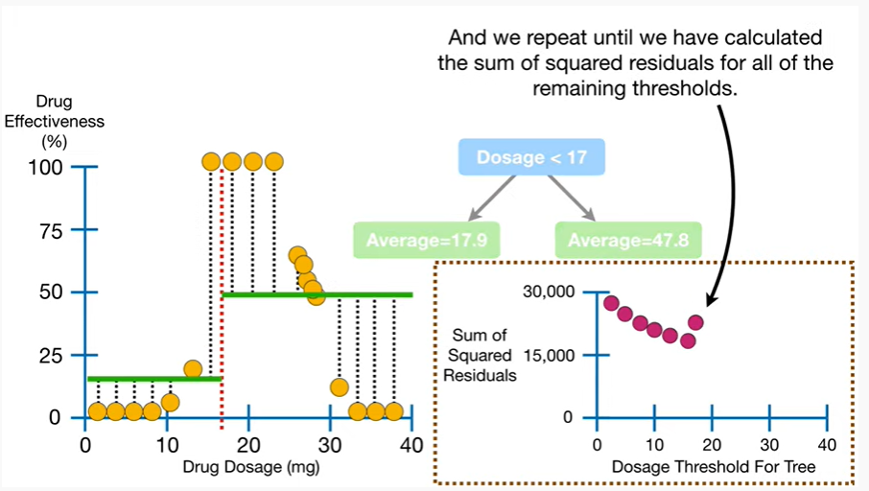

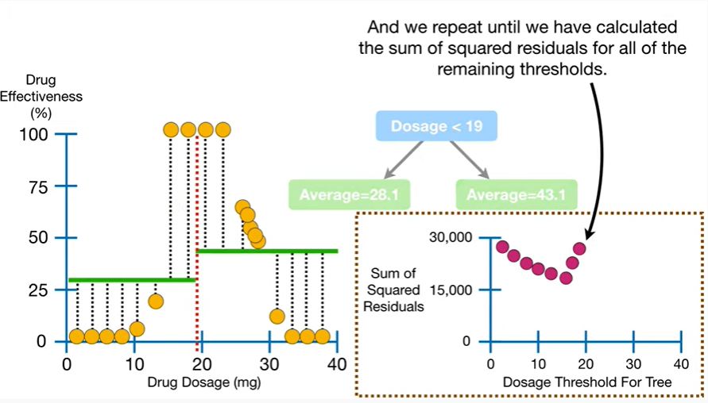

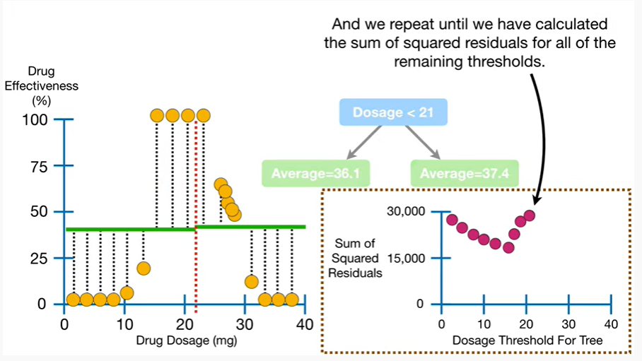

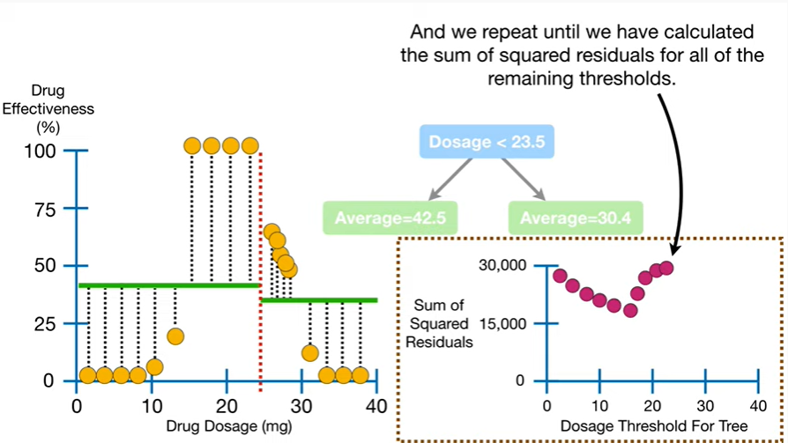

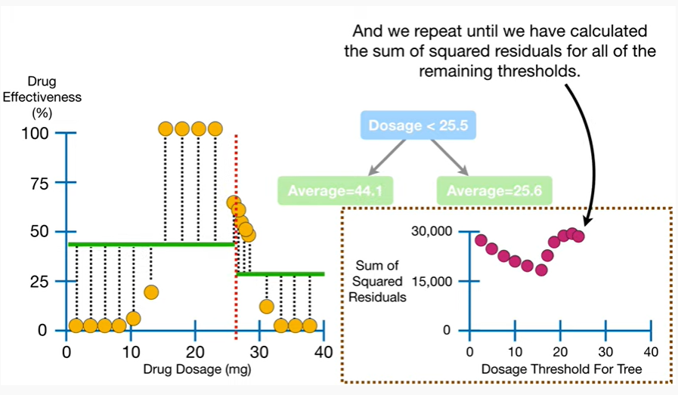

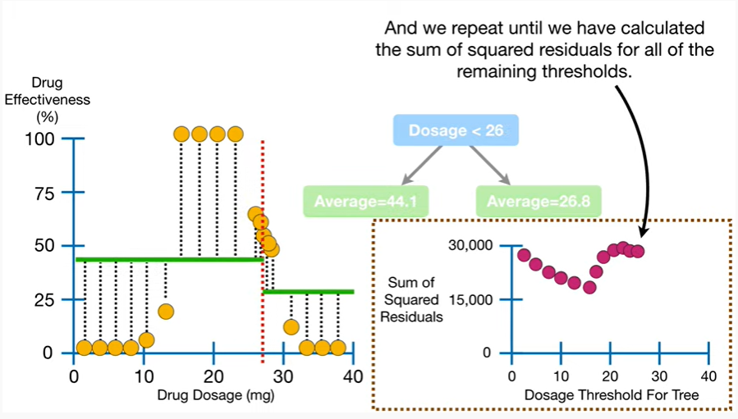

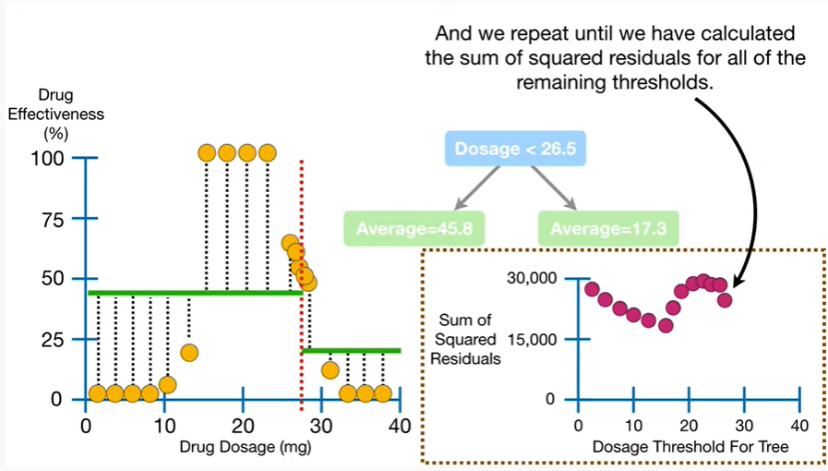

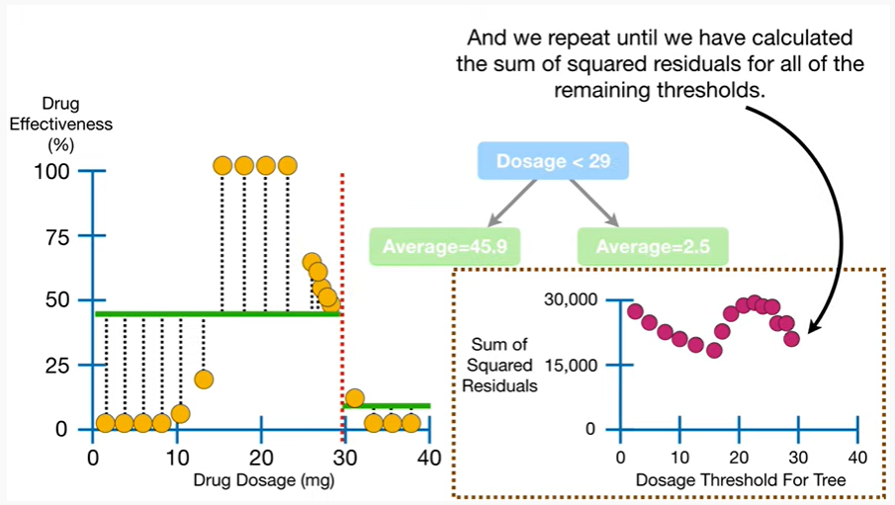

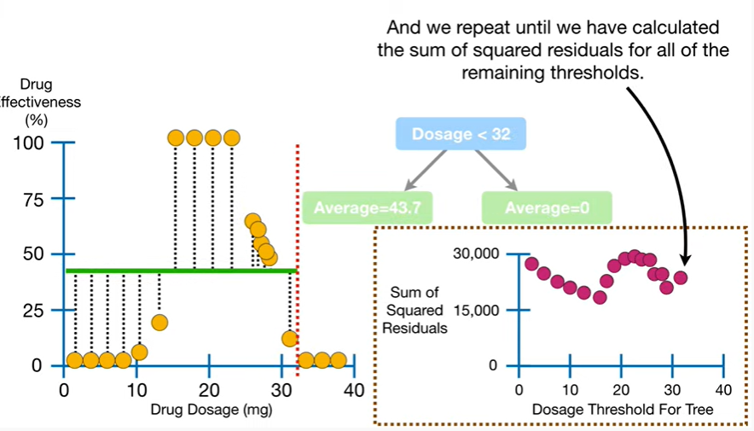

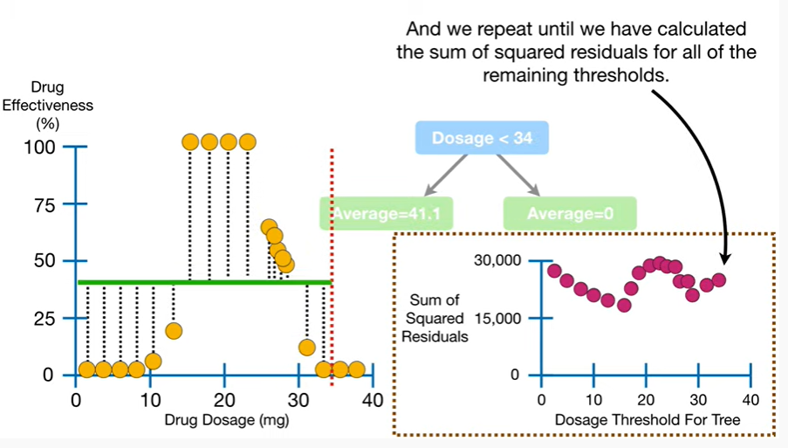

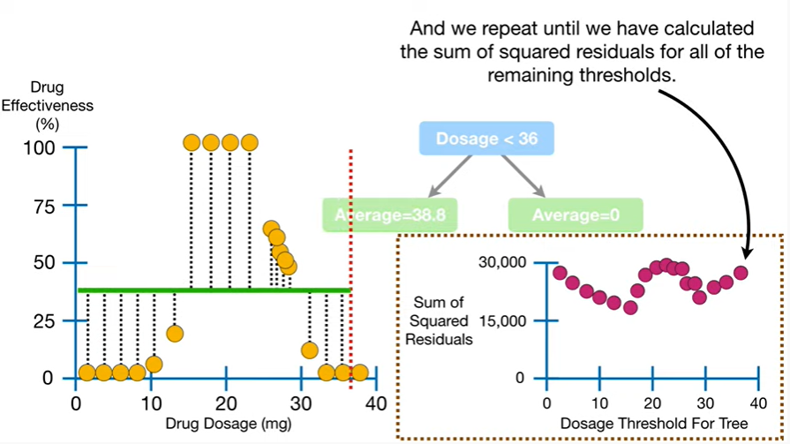

T 2 T 2 2 2 2 2 2

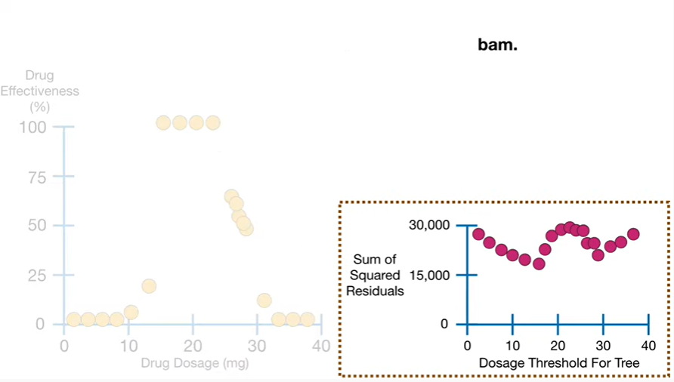

BAM.

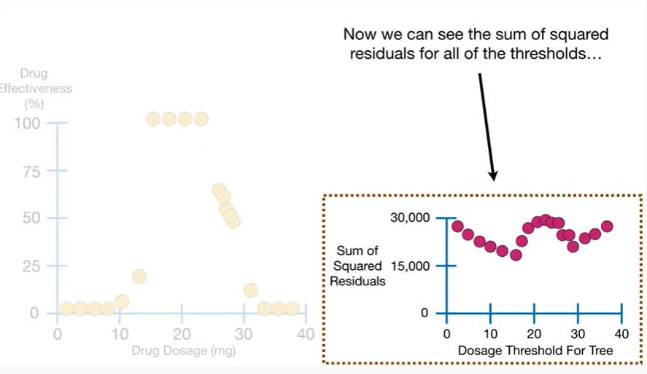

Now we can see the sum of squared residuals for all of the thresholds

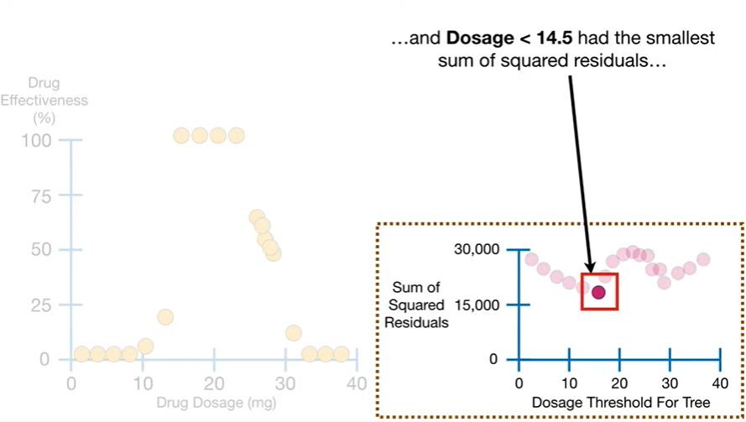

and dosage less than 14.5 has the smallest sum of squared residuals

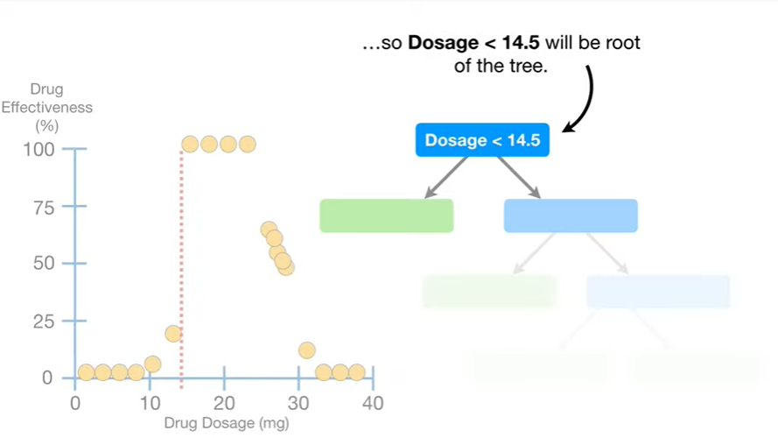

so dosage less than 14.5 will be the root of the tree.

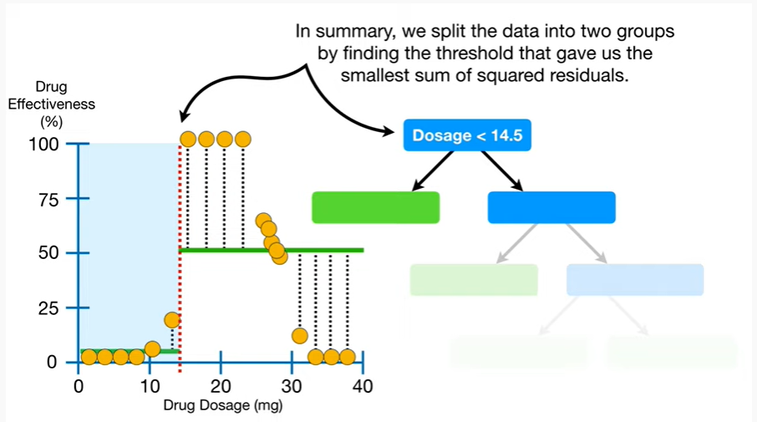

In summary, we split the data into two groups by finding the threshold that gave us the smallest sum of squared residuals.

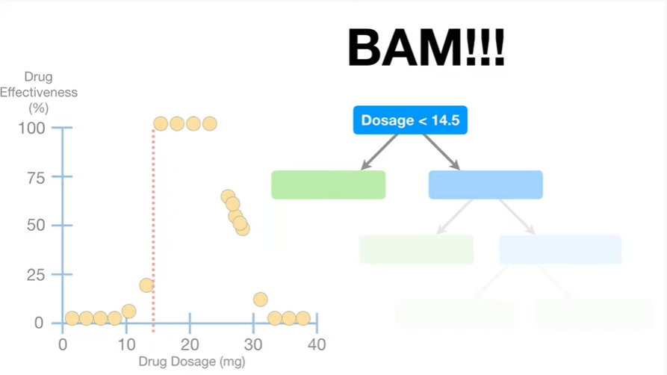

BAM !!!

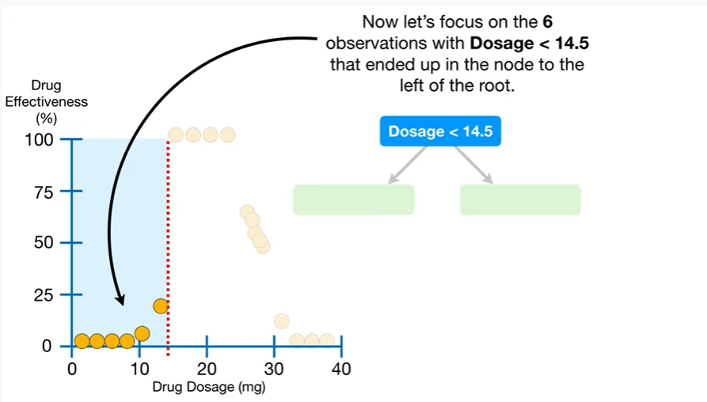

Now let's focus on the six observations with dosage less than 14.5 that ended up in the node to the left of the root.

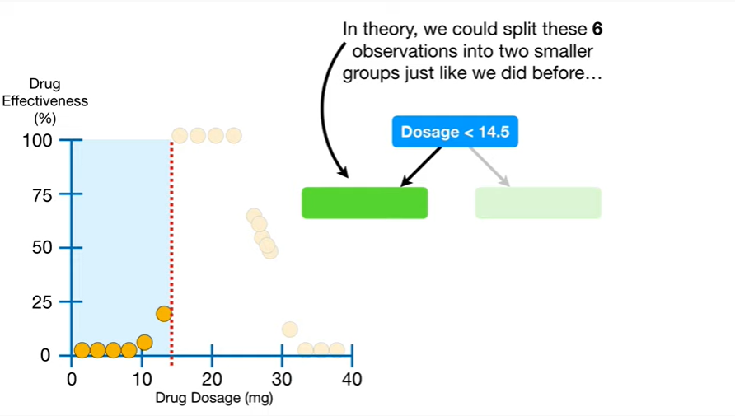

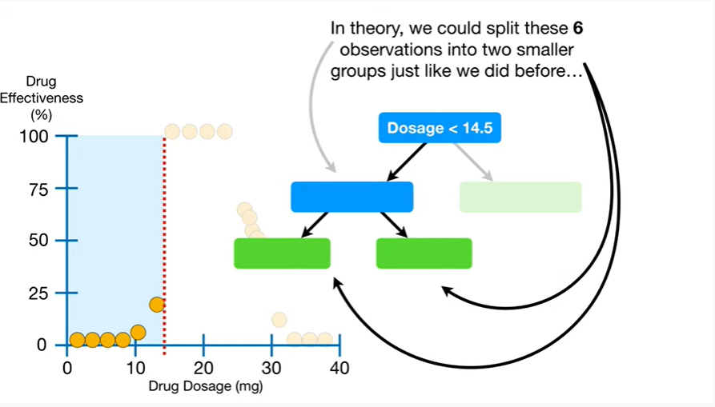

In theory we could split these six observations into two smaller groups just like we did before

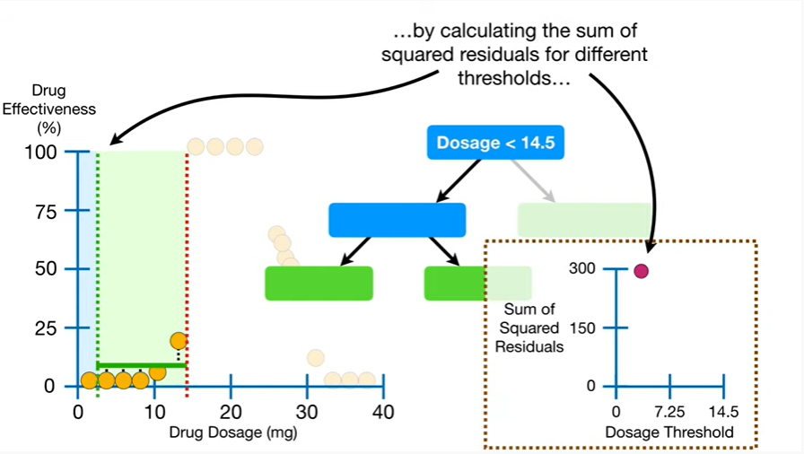

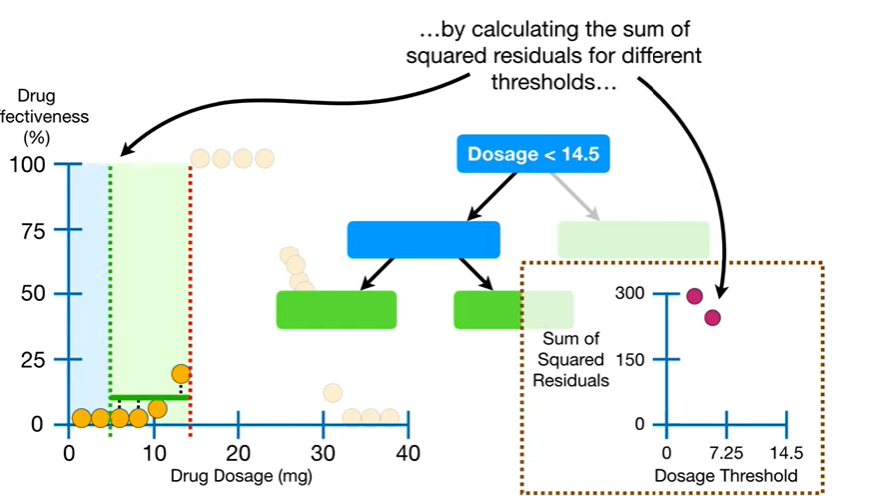

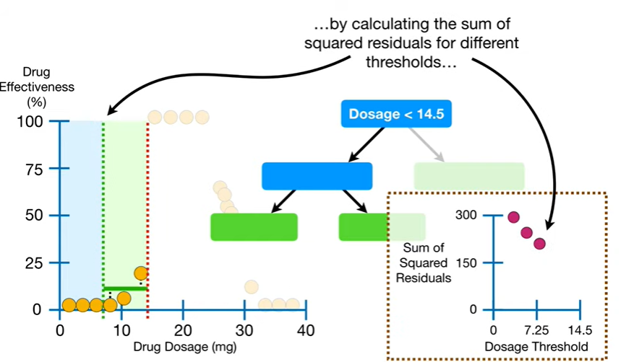

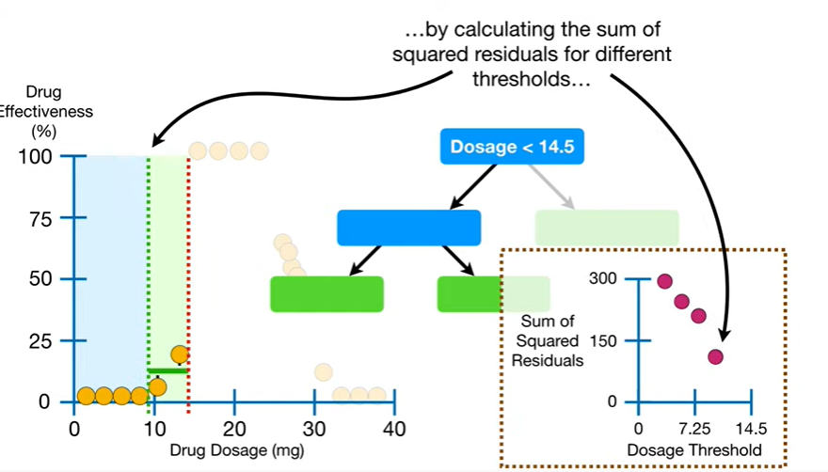

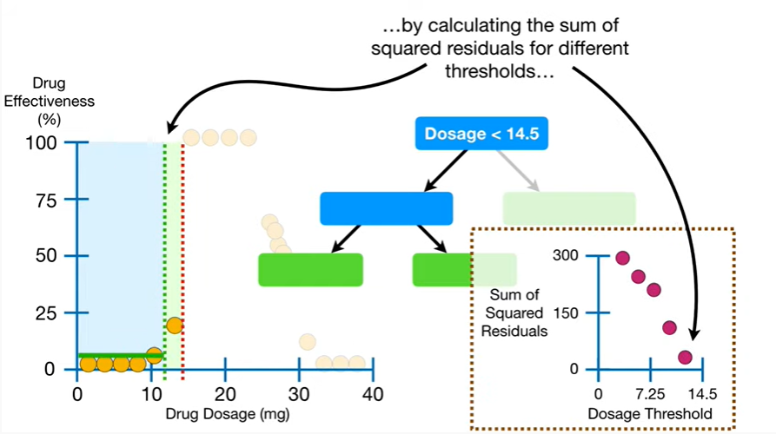

by calculating the sum of squared residuals for different thresholds

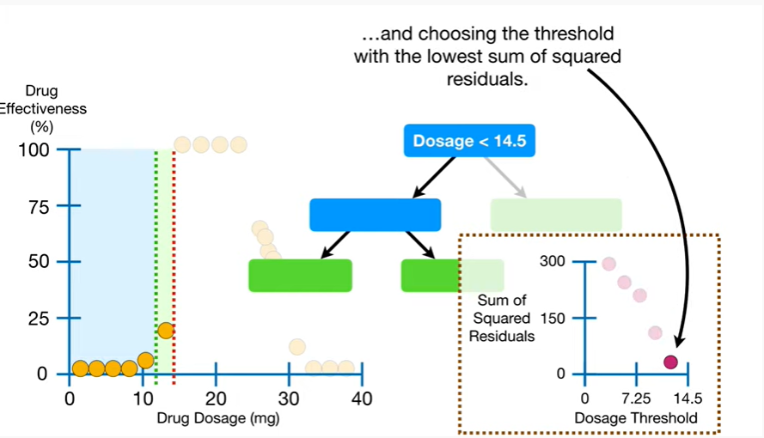

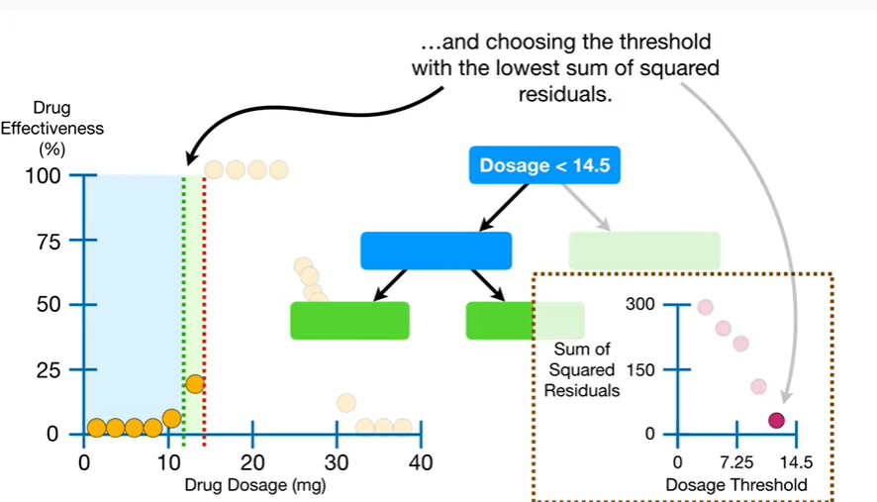

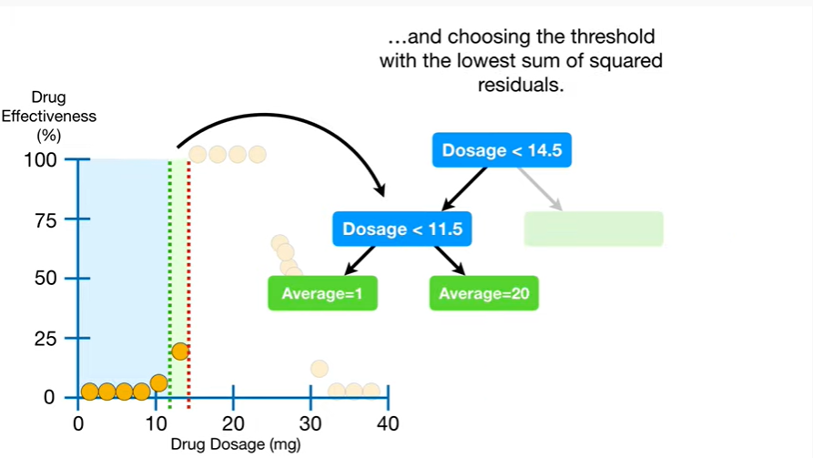

and choosing the threshold with the lowest sum of squared residuals.

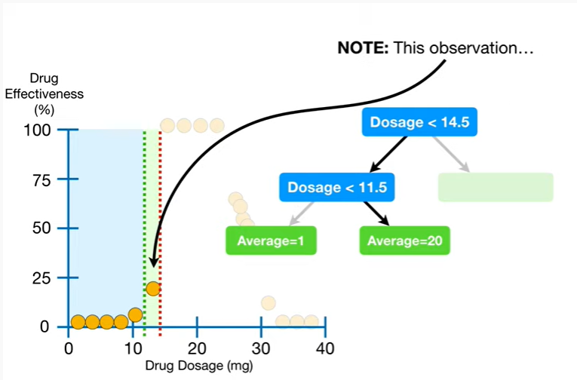

Note : this observation

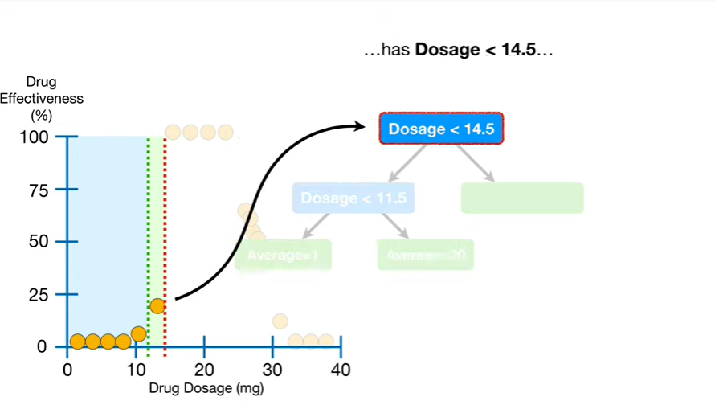

has dosage less than 14.5

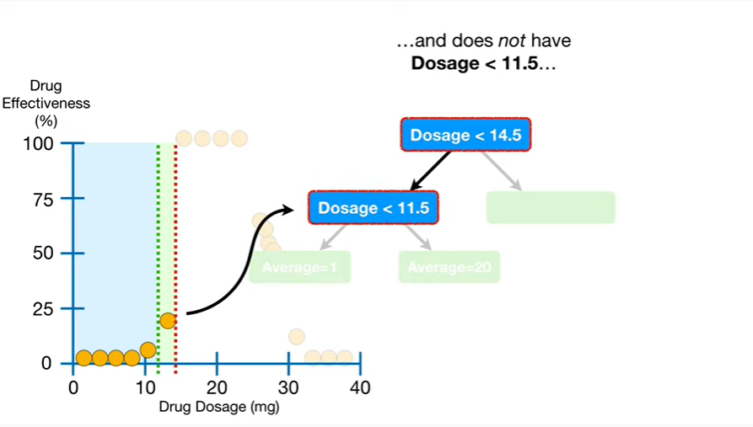

and does not have dosage less than 11.5

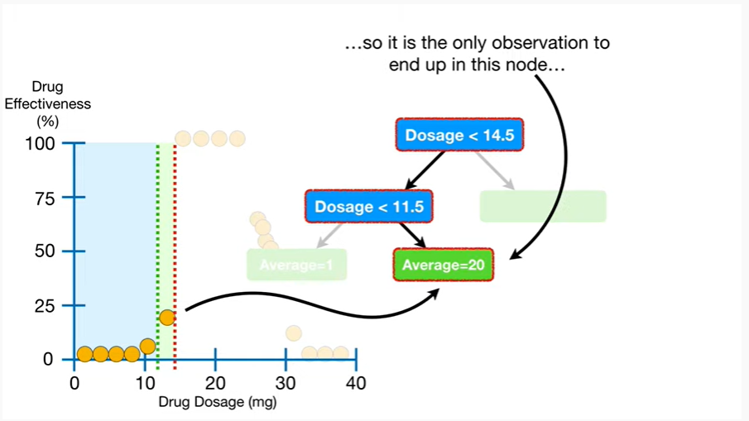

so it is the only observation to end up in this node

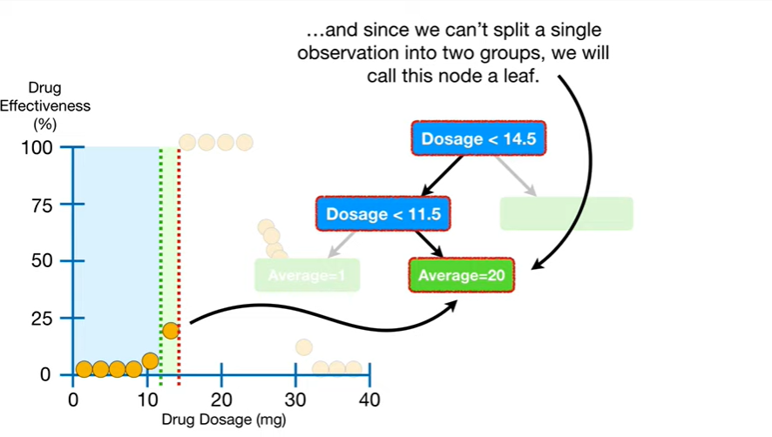

and since we can't split a single observation into two groups we will call this node a leaf.

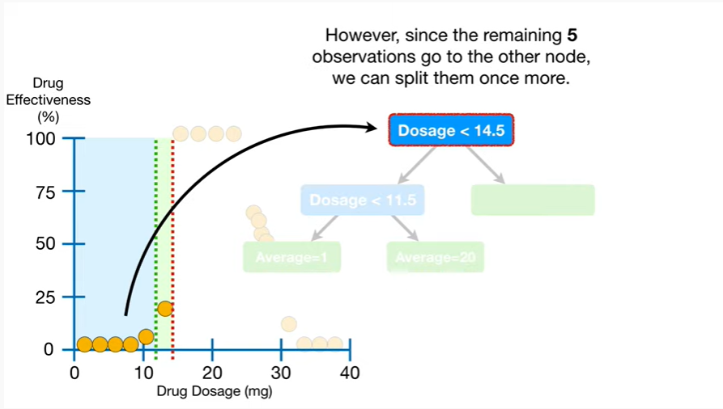

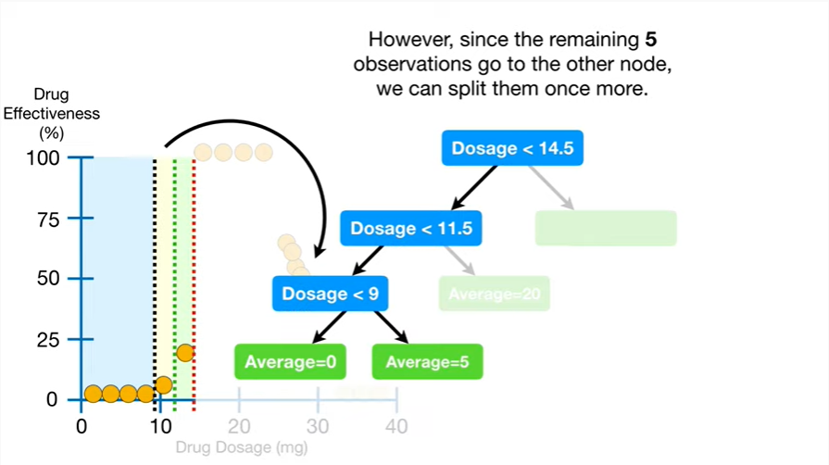

However since the remaining five observations go to the other node we can split them once more.

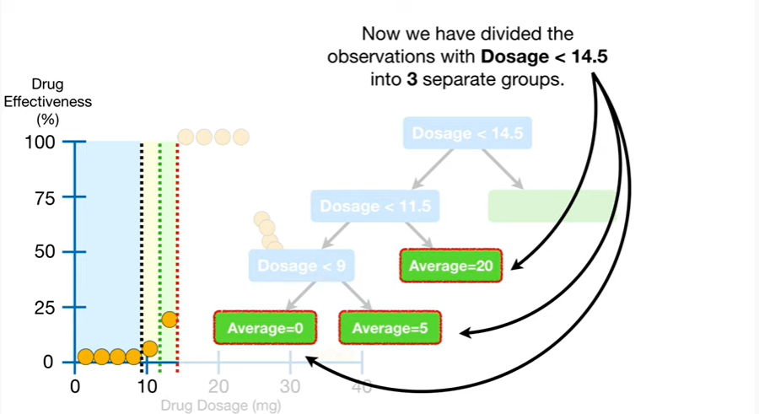 Now we have divided the observations with dosage less than 14.5 into three separate groups.

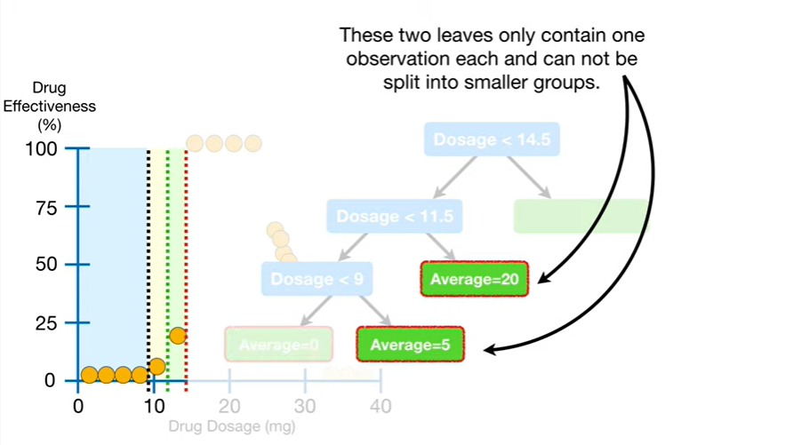

These two leaves only contain one observation each and cannot be split into smaller groups.

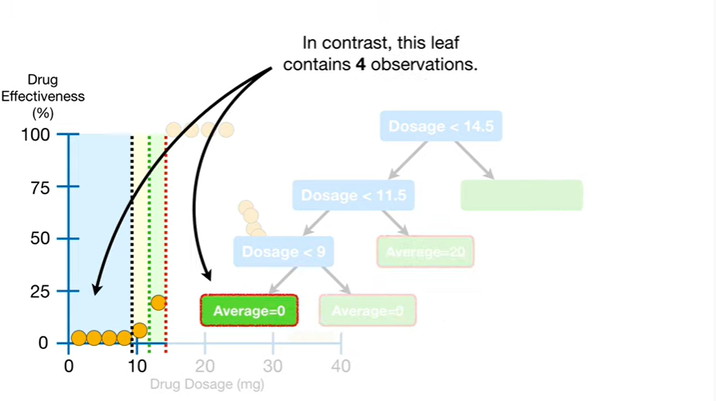

In contrast this leaf contains four observations.

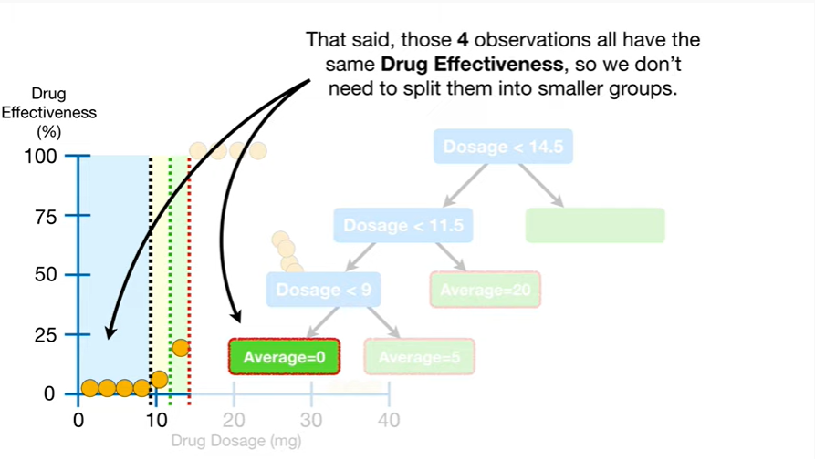

That said, those four observations all have the same drug effectiveness, so we don't need to split them into smaller groups.

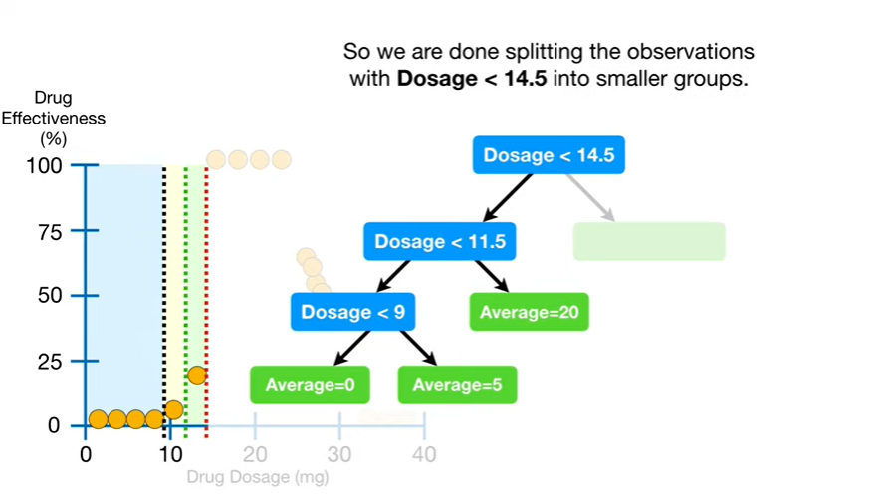

So we are done splitting the observations with dosage less than 14.5 into smaller groups.

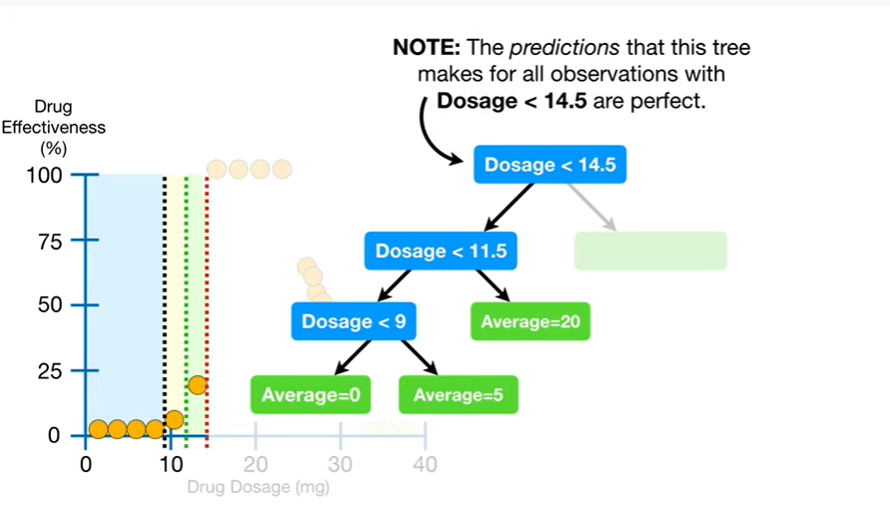

Note : the predictions that this tree makes for all observations with dosage less than 14.5 are perfect.

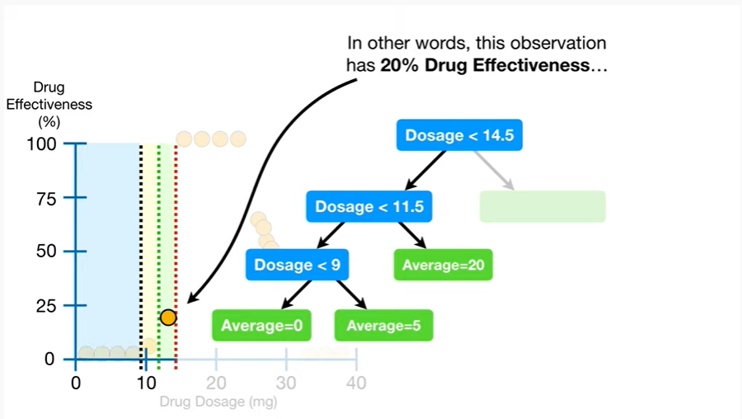

In other words, this observation has 20% drug effectiveness

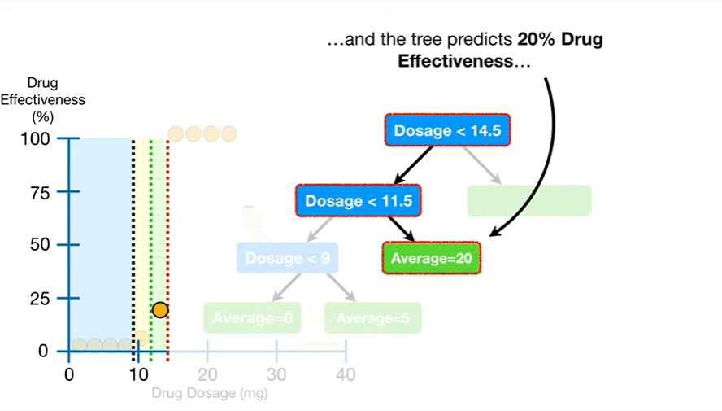

and the tree predicts 20% drug effectiveness

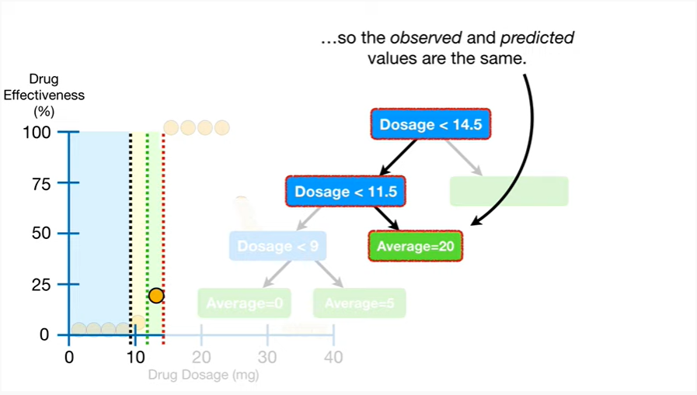

so the observed and predicted values are the same.

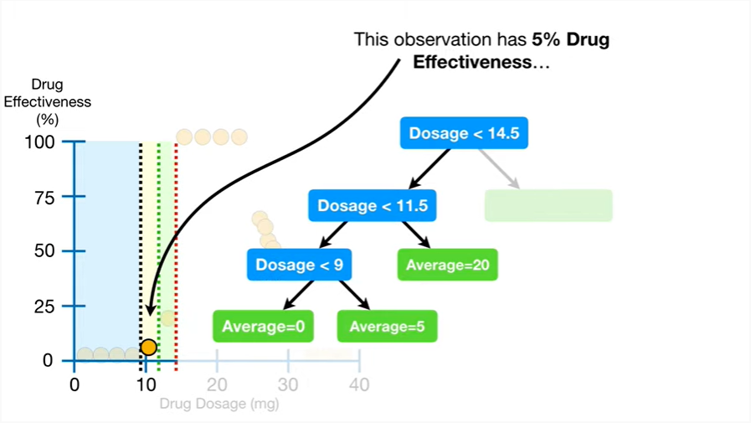

This observation has 5% drug effectiveness

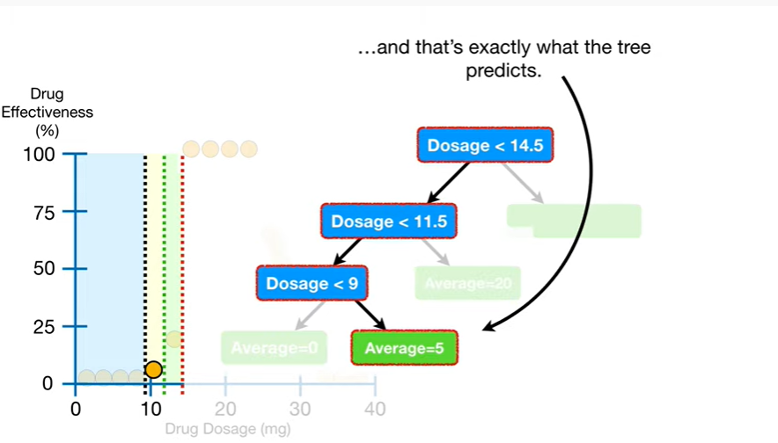

and that's exactly what the tree predicts.

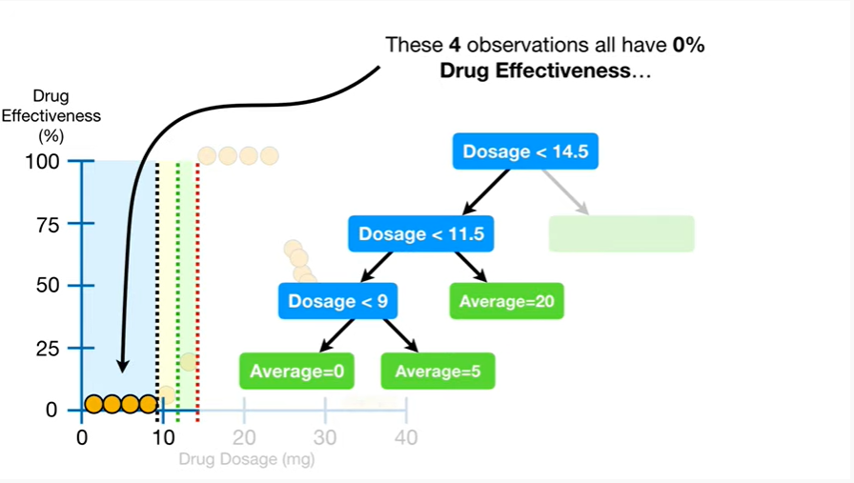

These four observations all have 0% drug effectiveness

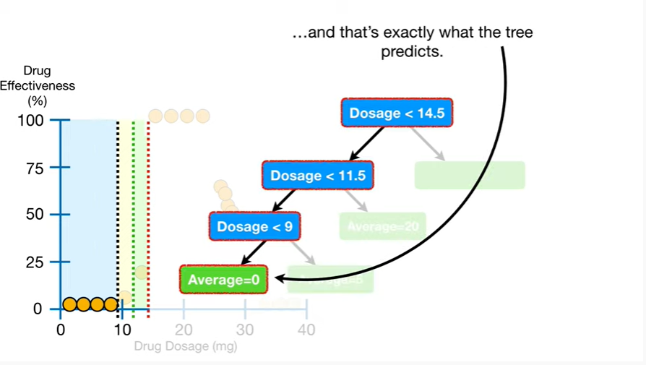

and that's exactly what the tree predicts.

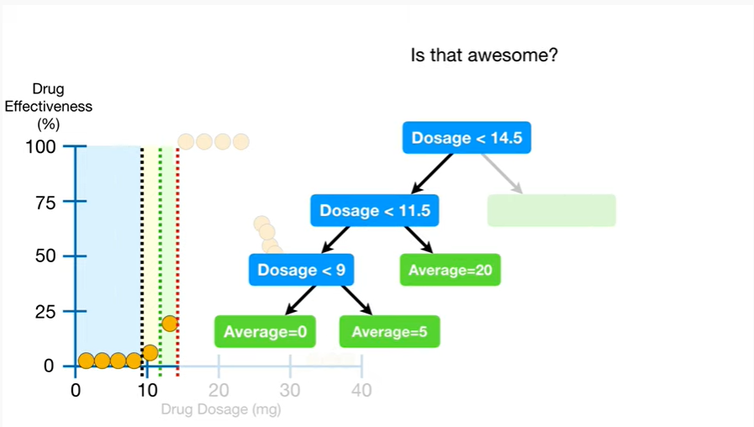

Is that awesome ?

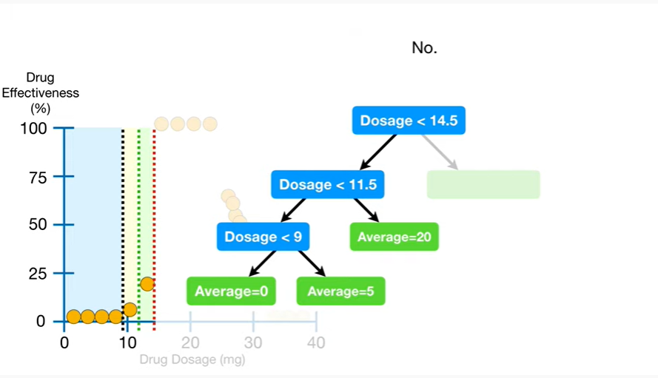

No.

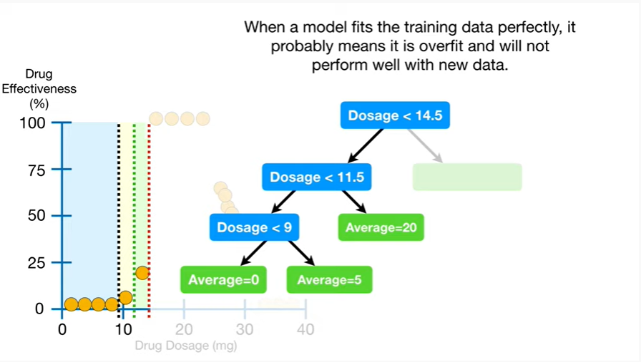

When a model fits the training data perfectly, it probably means it is over fit and will not perform well with new data.

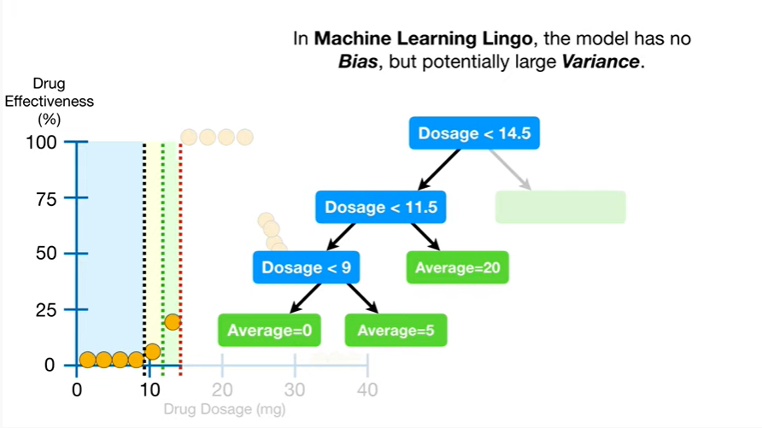

In machine learning lingo, the model has no bias, but potentially large variance.

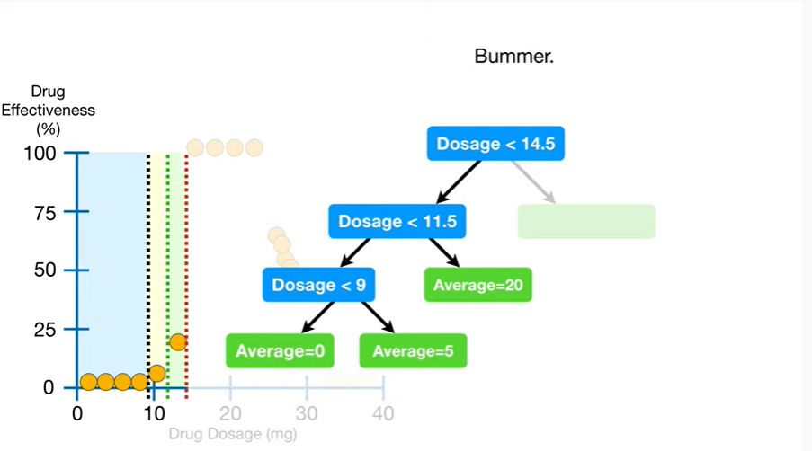

Bummer.

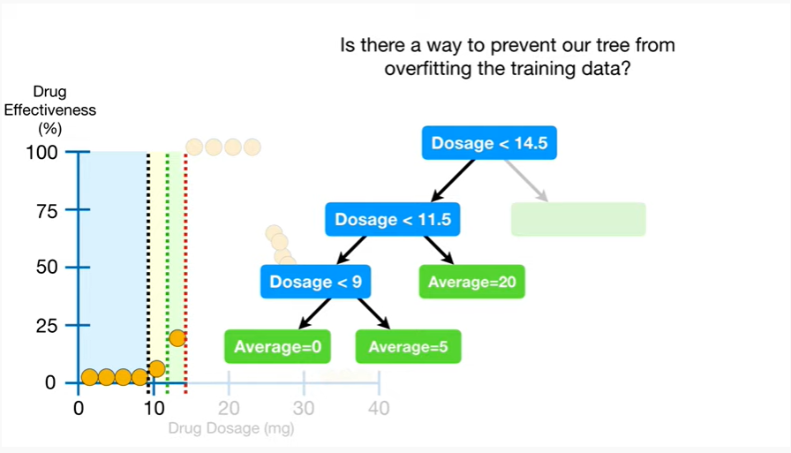

Is there a way to prevent our tree from overfitting the training data ?

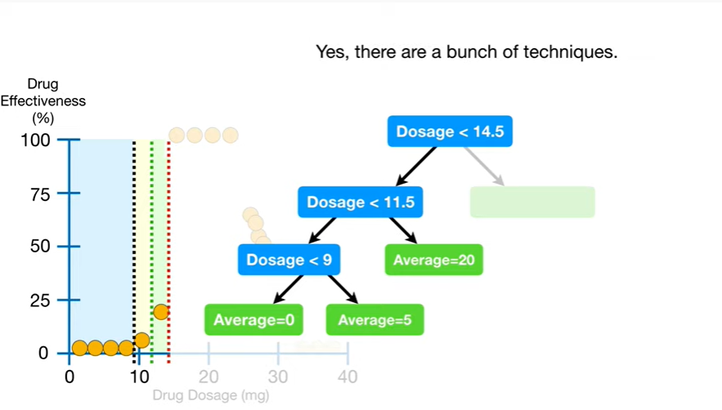

Yes there are a bunch of techniques.

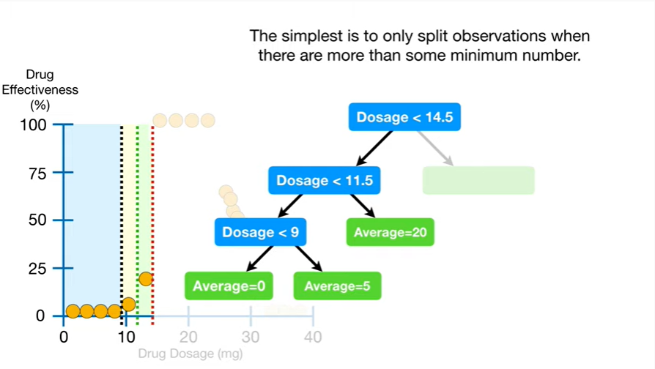

The simplest is to only split observations when there are more than some minimum number.

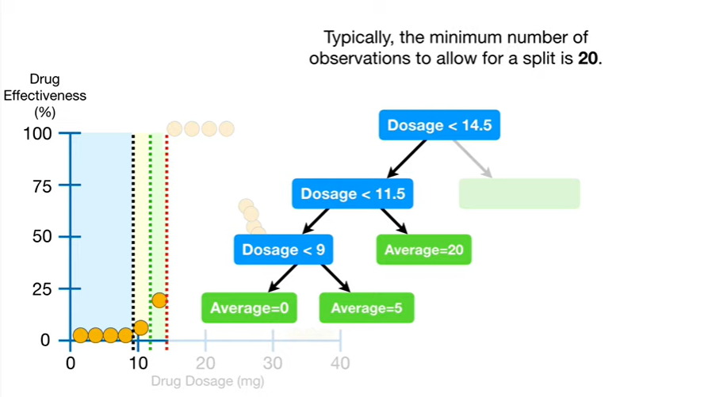

Typically the minimum number of observations to allow for a split is 20.

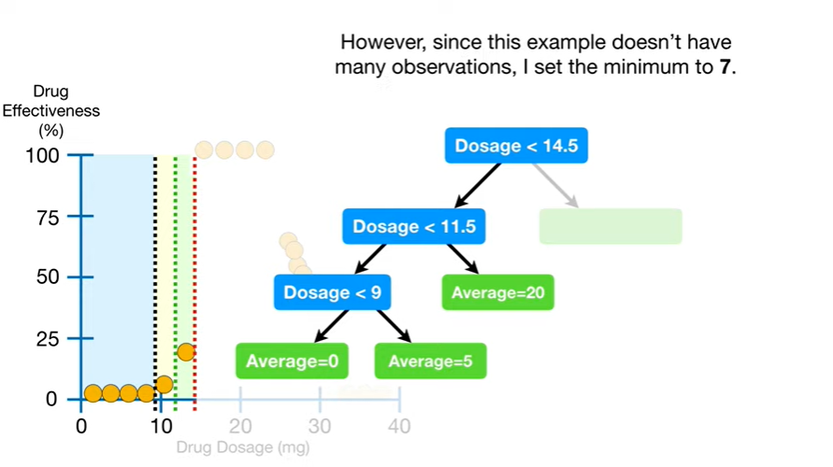

However since this example doesn't have many observations, I set the minimum to 7.

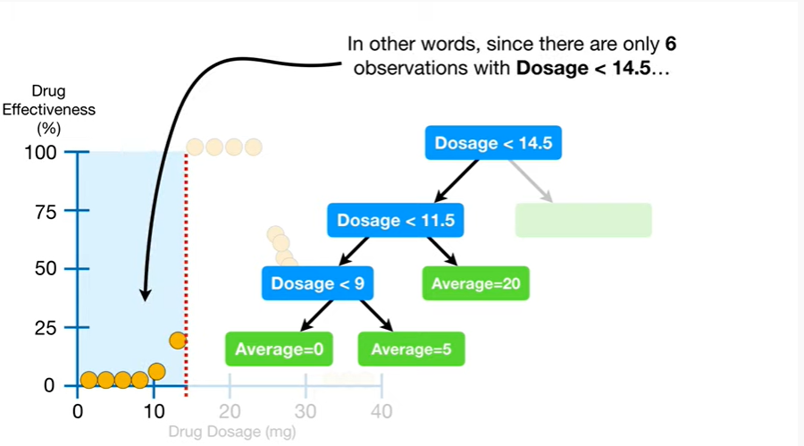

In other words, since there are only six observations with dosage less than 14.5

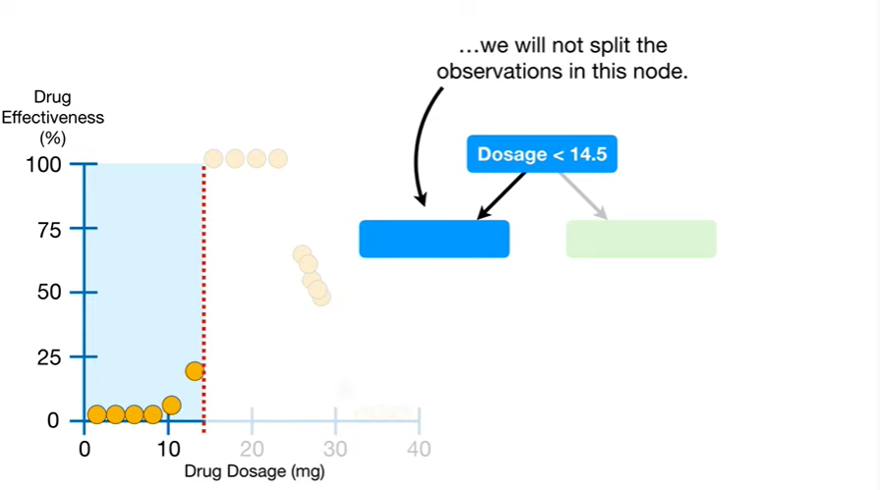

we will not split the observations in this node.

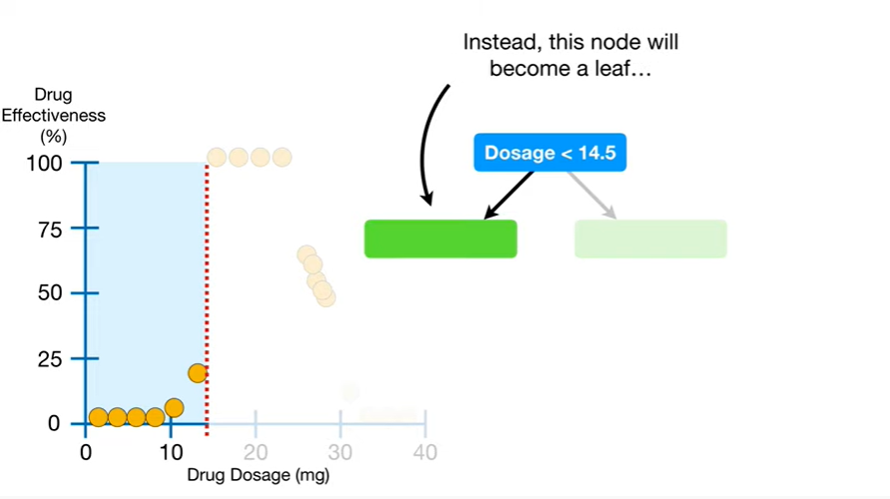

Instead, this node will become a leaf

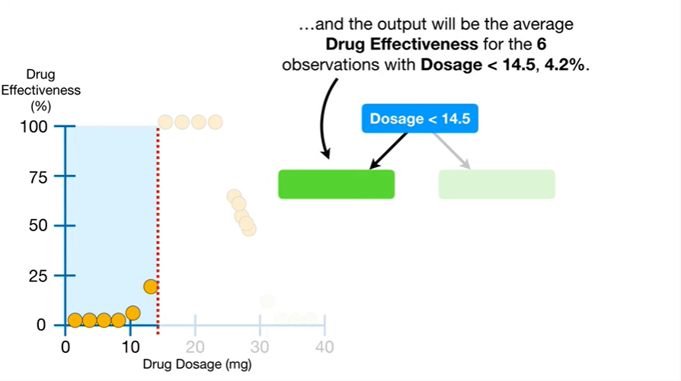

and the output will be the average drug effectiveness for the six observations with dosage less than 14.5,

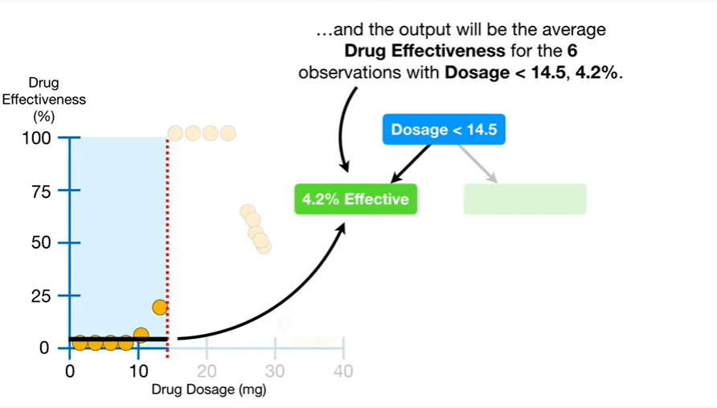

4.2%.

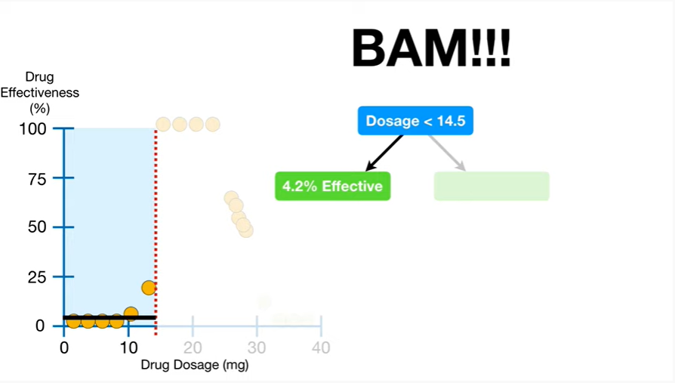

BAM !!!

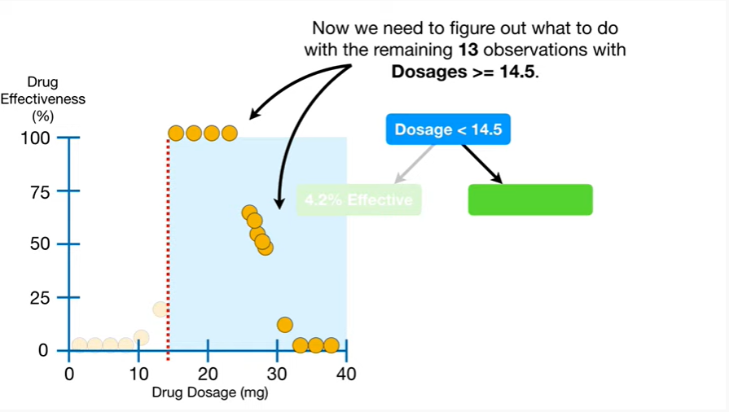

Now we need to figure out what to do with the remaining 13 observations with dosages greater than or equal to 14.5.

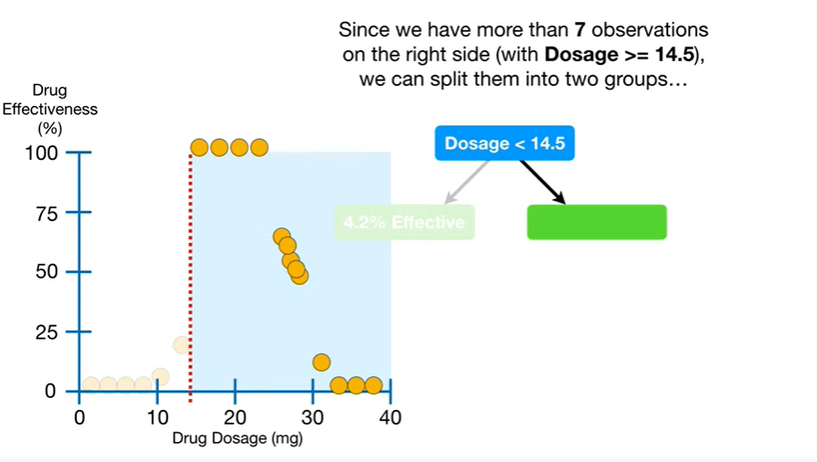

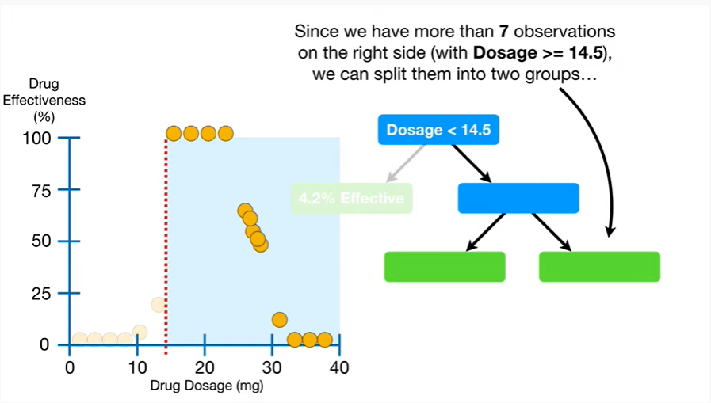

Since we have more than 7 observations on the right side (with dosage>=14.5), we can split them into two groups

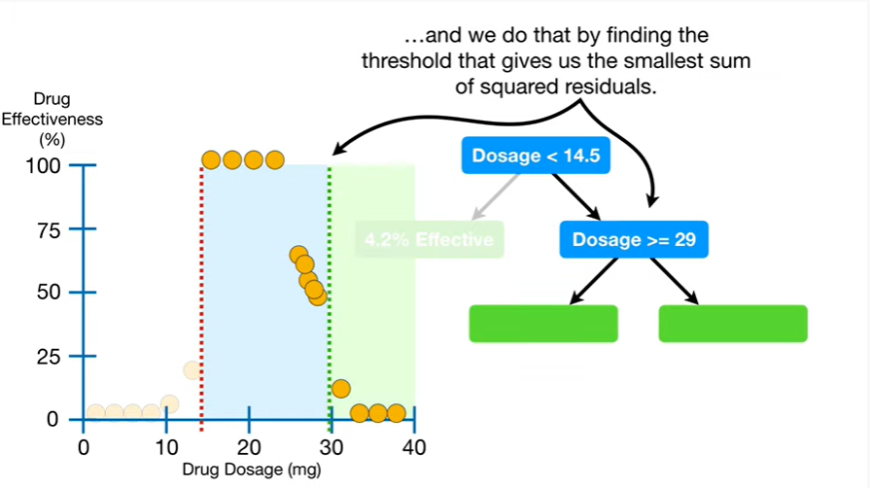

and we do that by finding the threshold that gives us the smallest sum of squared residuals.

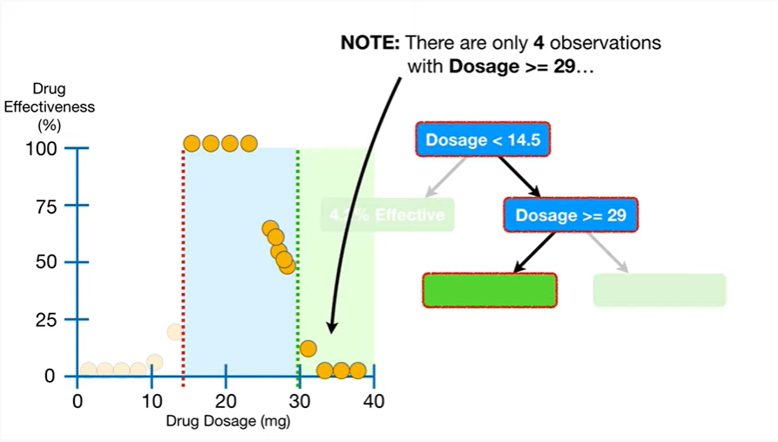

Note : there are only four observations with dosage greater than or equal to 29

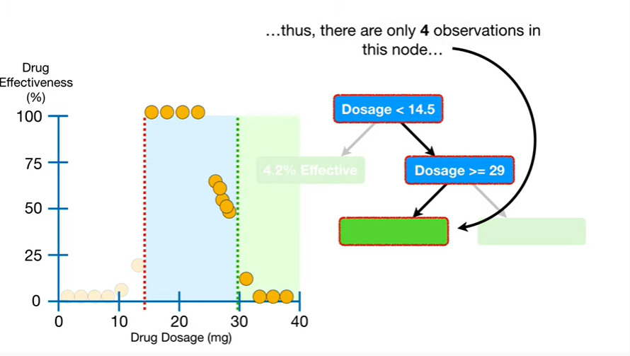

thus there are only four observations in this node

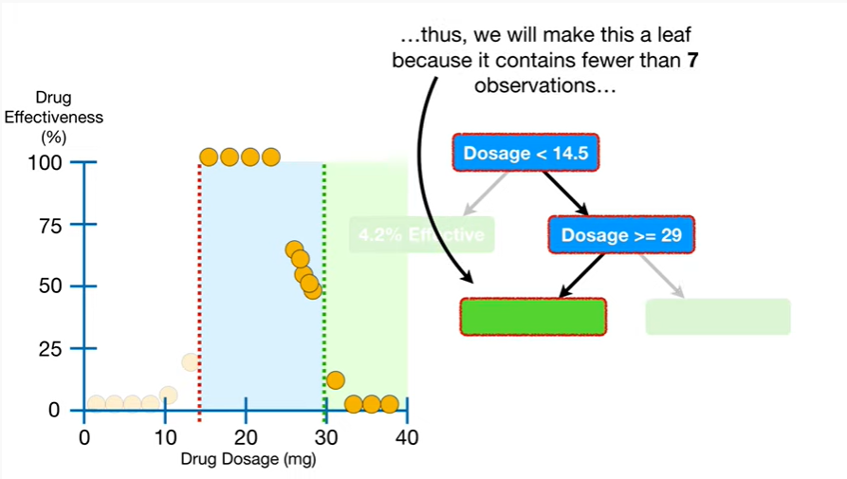

Thus, we will make this a leaf because it contains fewer than seven observations

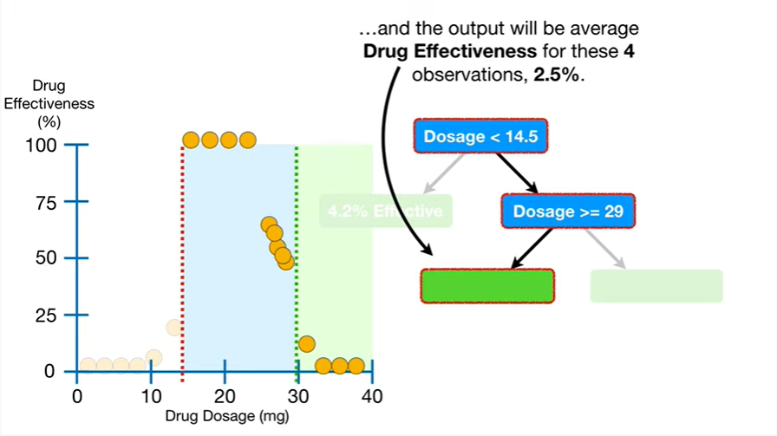

and the output will be the average drug effectiveness for these four observations,

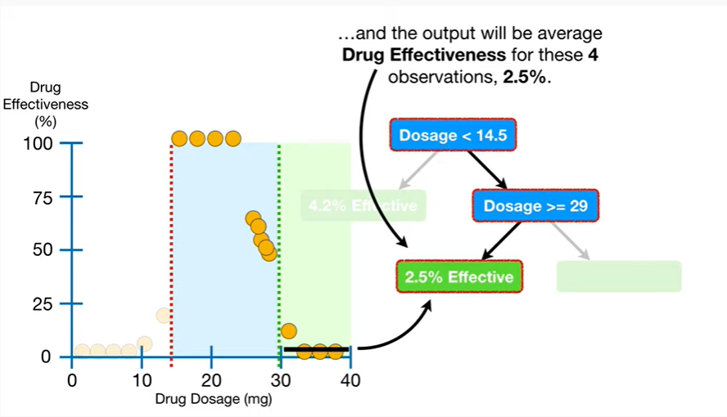

2.5%.

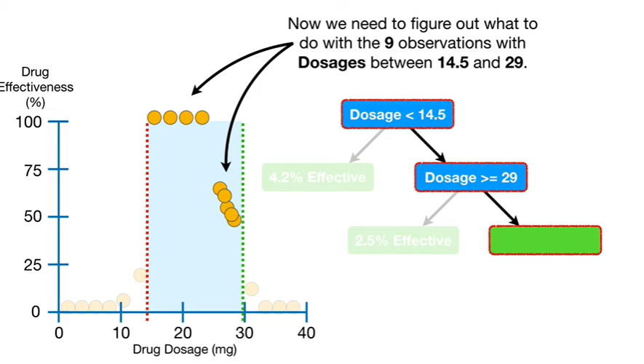

Now we need to figure out what to do with the nine observations with dosages between 14.5 and 29.

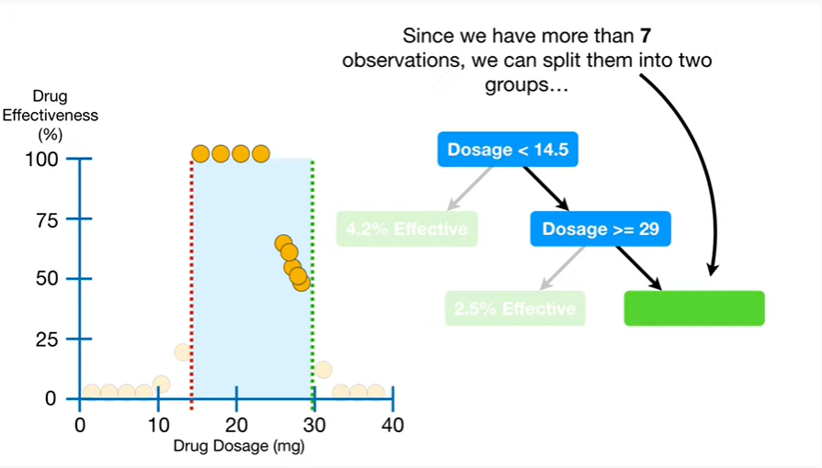

Since we have more than seven observations

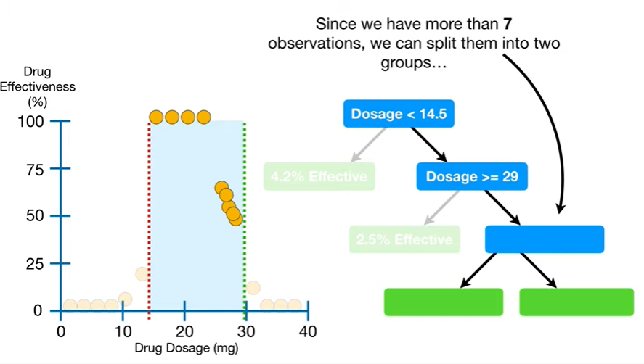

we can split them into two groups

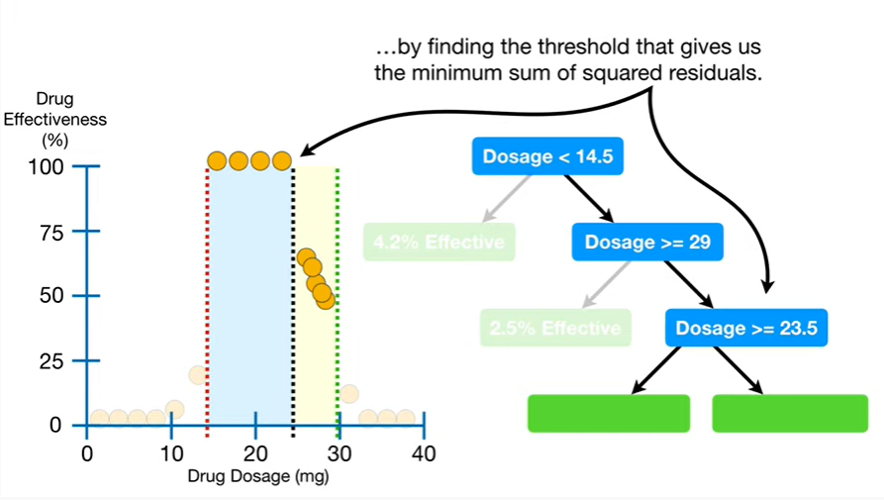

by finding the threshold that gives us the minimum sum of squared residuals.

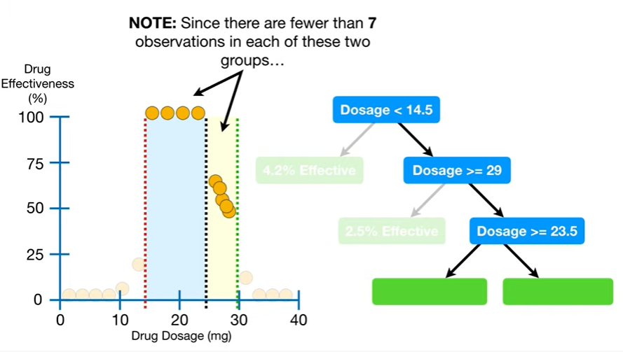

Note : since there are fewer than seven observations in each of these two groups this is the last split because none of the leaves have more than seven observations in them.

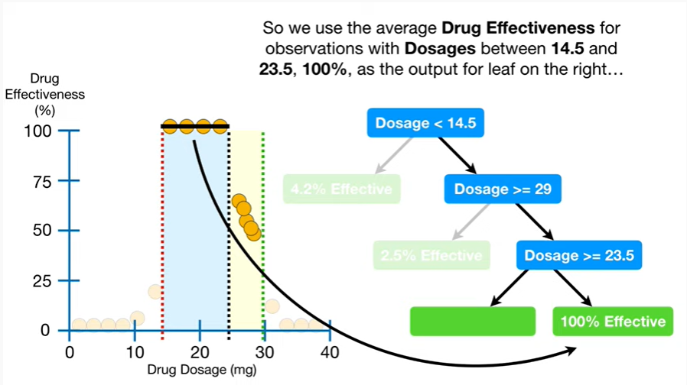

So we use the average drug effectiveness for the observations with dosages between fourteen point five and twenty-three point five, one hundred percent, as the output for the leaf on the right

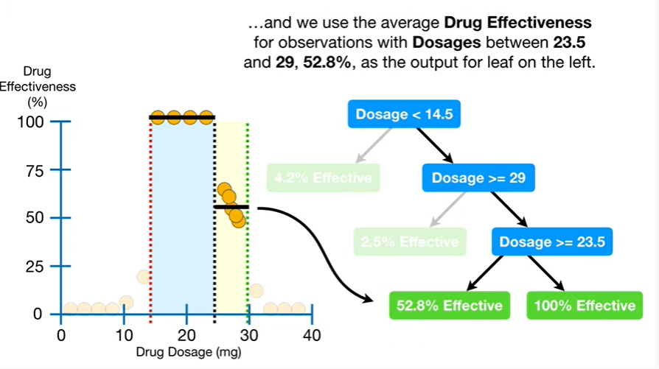

and we use the average drug effectiveness for observations with dosages between twenty three point five and twenty nine, fifty two point eight percent as the output for the leaf on the Left.

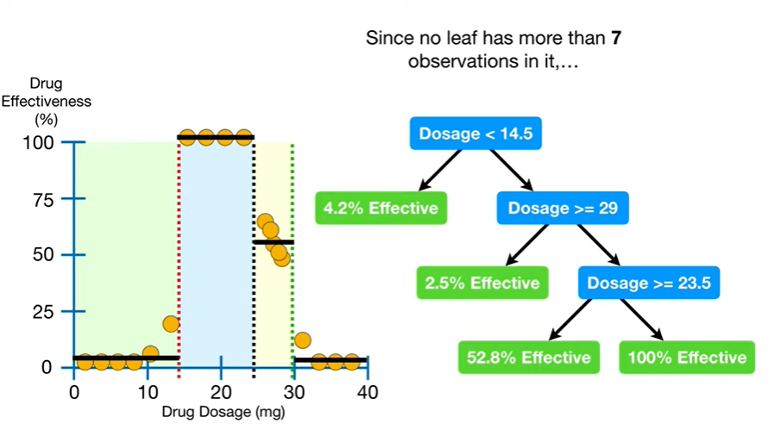

Since no leaf has more than seven observations in it

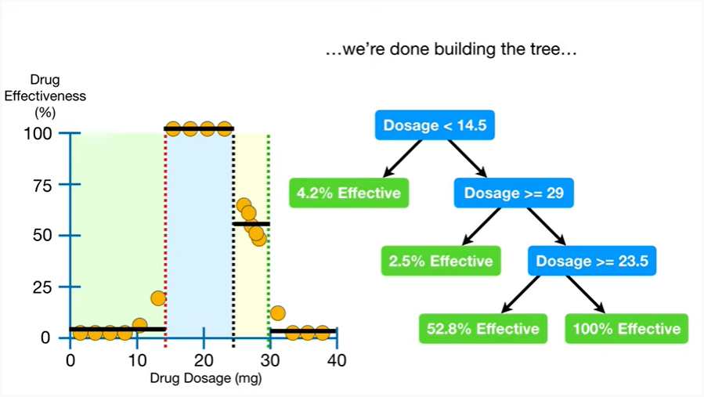

were done building the tree

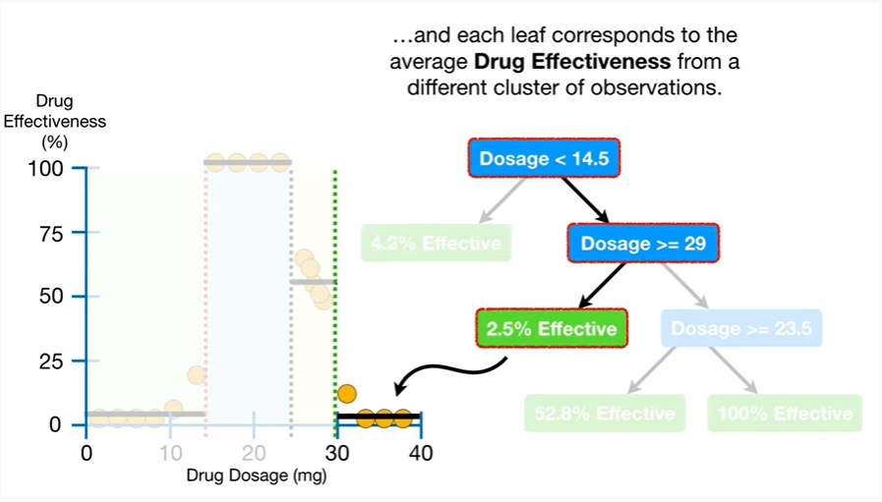

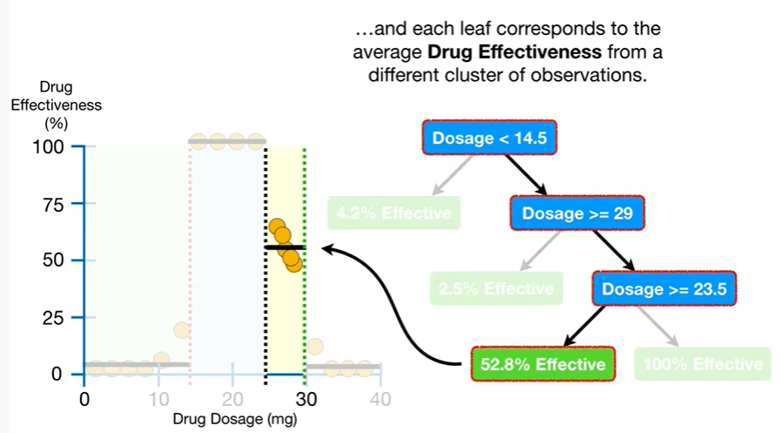

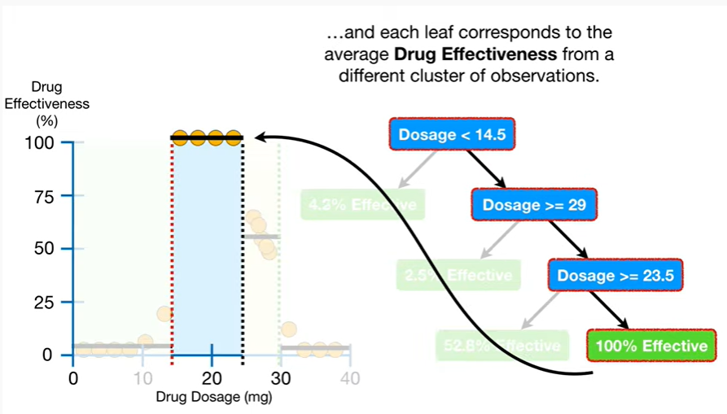

and each leaf corresponds to the average drug effectiveness from a different cluster of observations.

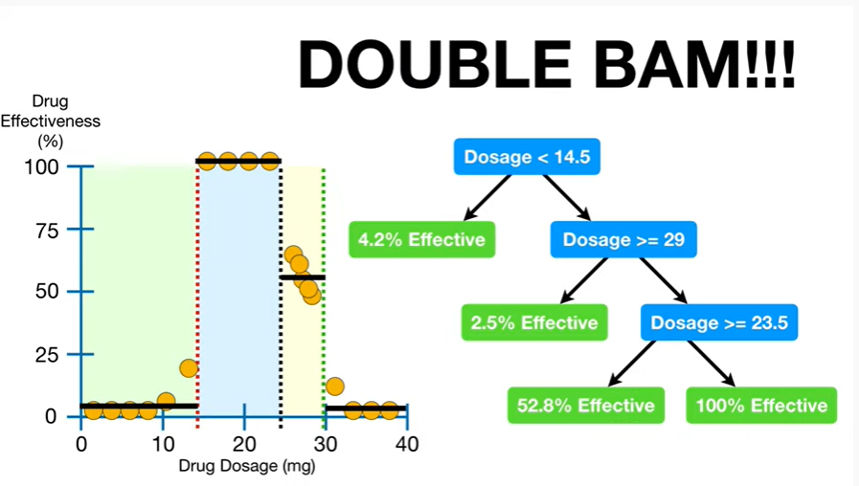

Double BAM !!!

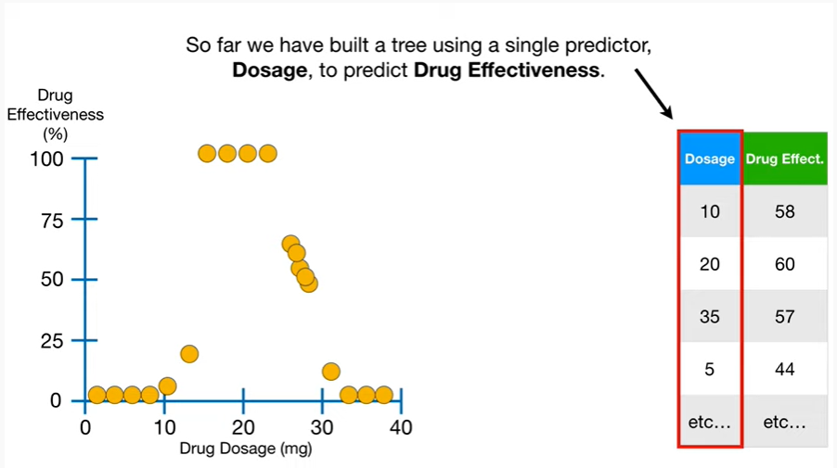

So far we have built a tree using a single predictor, dosage, to predict drug effectiveness.

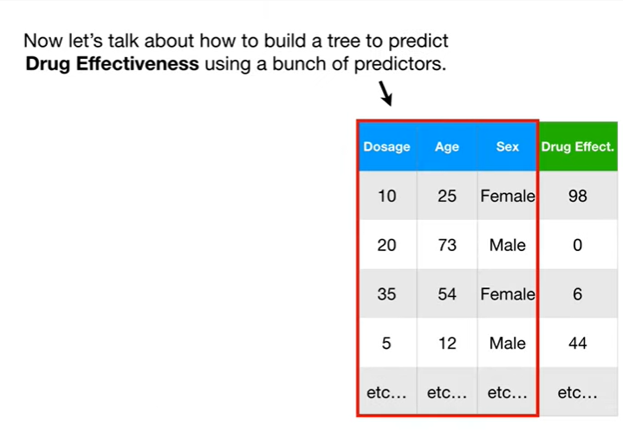

Now let's talk about how to build a tree to predict drug effectiveness using a bunch of predictors.

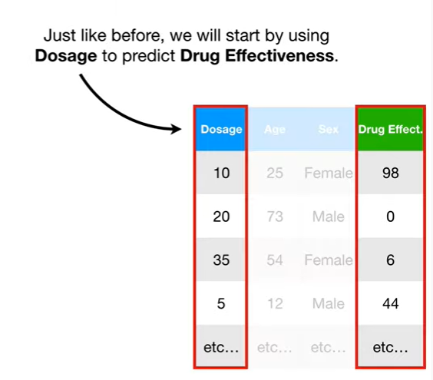

Just like before, we will start by using dosage to predict drug effectiveness.

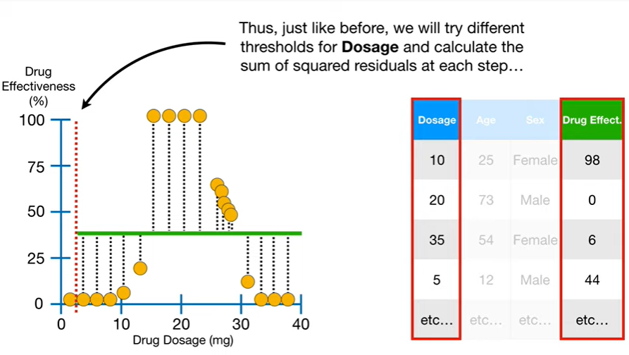

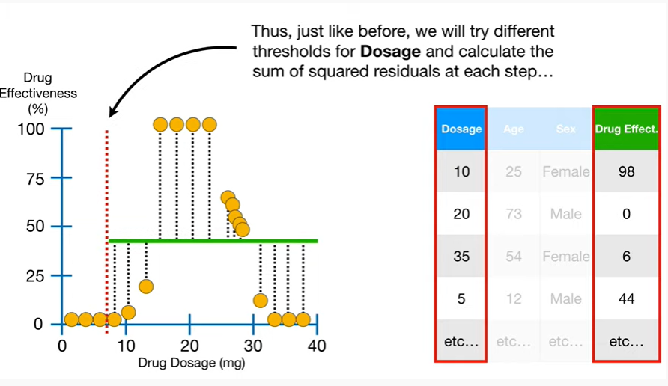

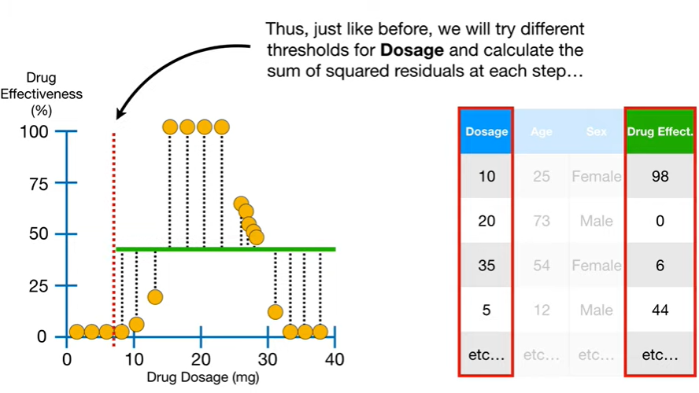

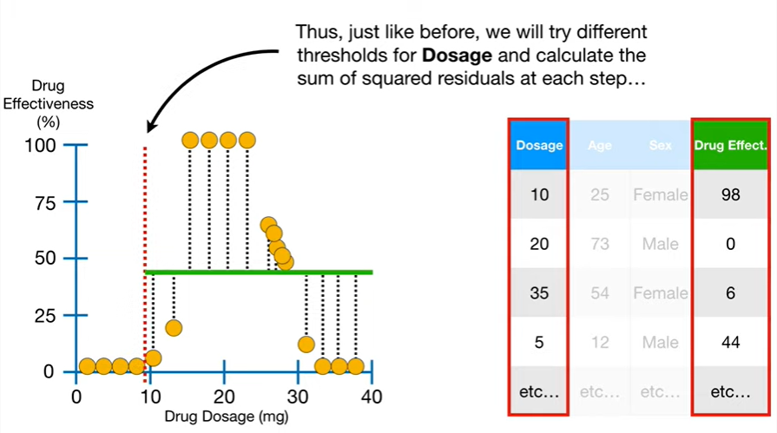

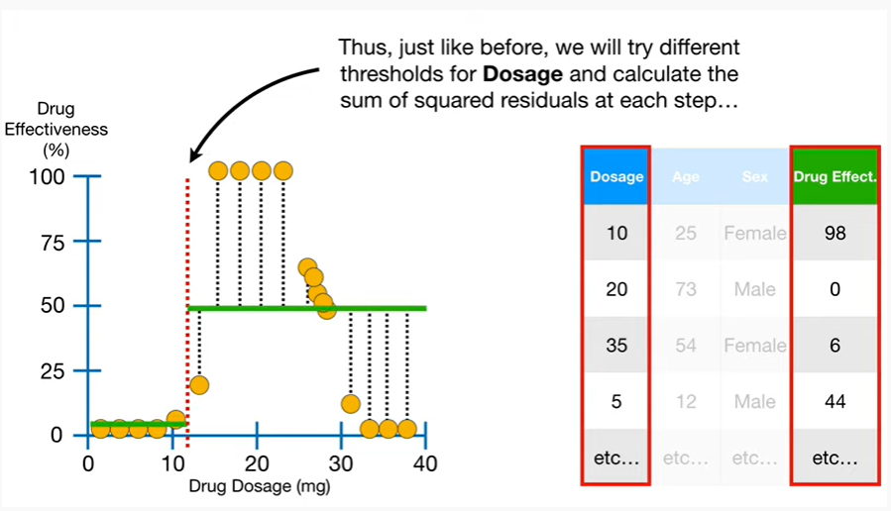

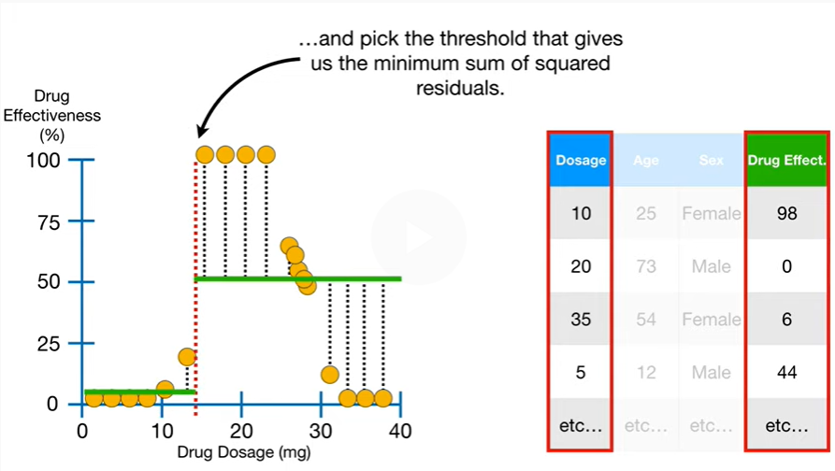

Thus, just like before we will try different thresholds for dosage and calculate the sum of squared residuals at each step

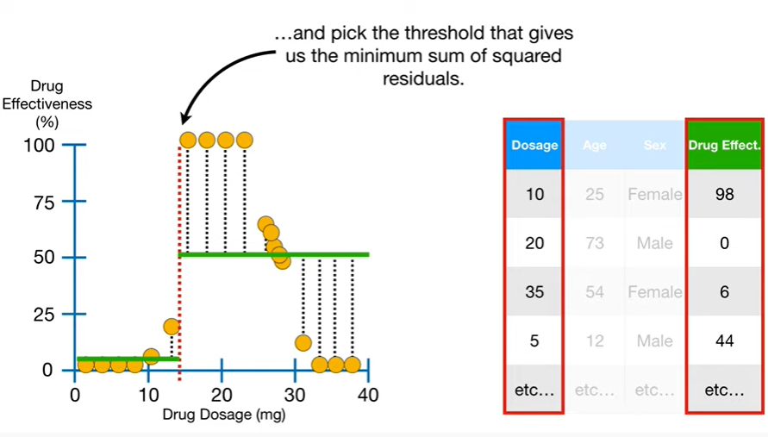

and pick the threshold that gives us the minimum sum of squared residuals.

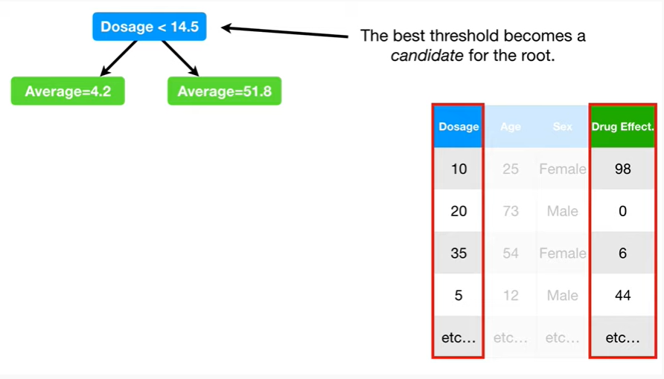

The best threshold becomes a candidate for the root.

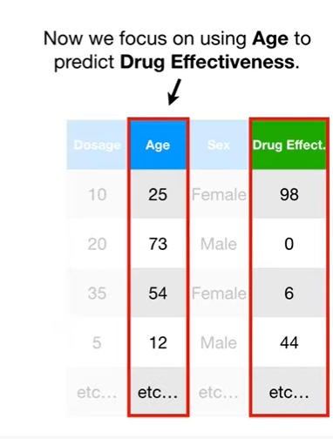

Now we focus on using age to predict drug effectiveness.

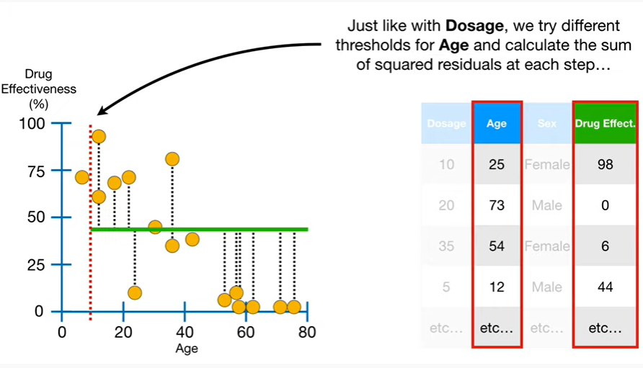

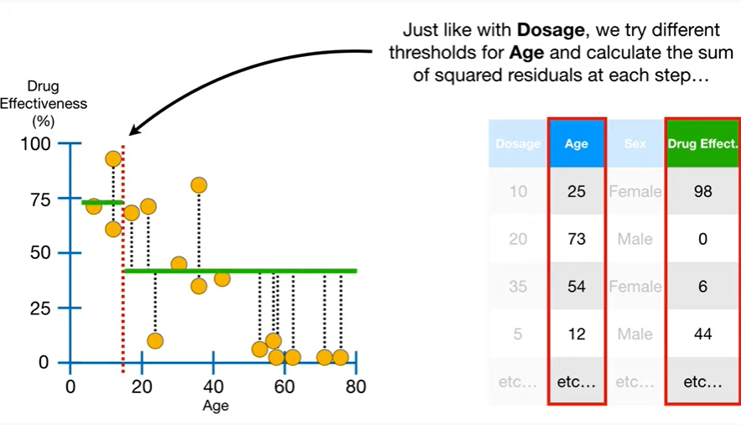

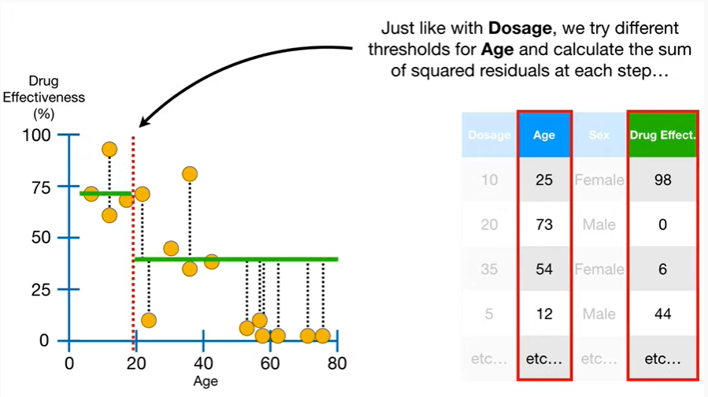

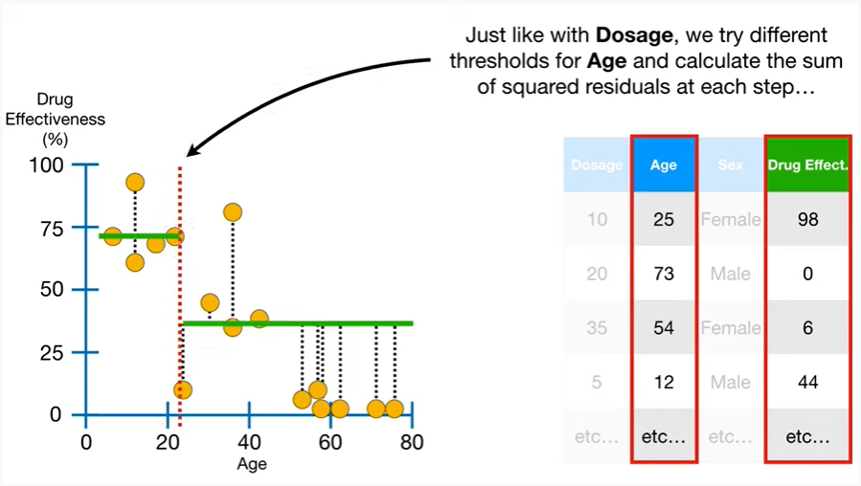

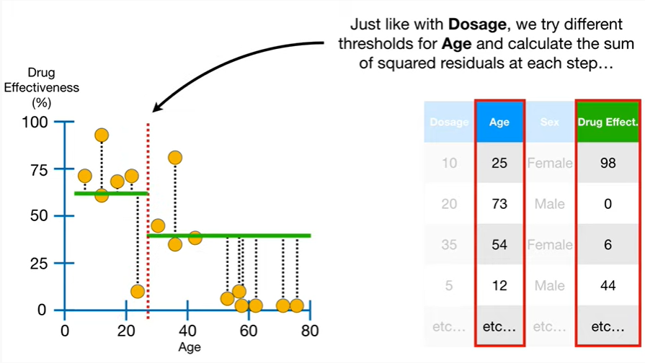

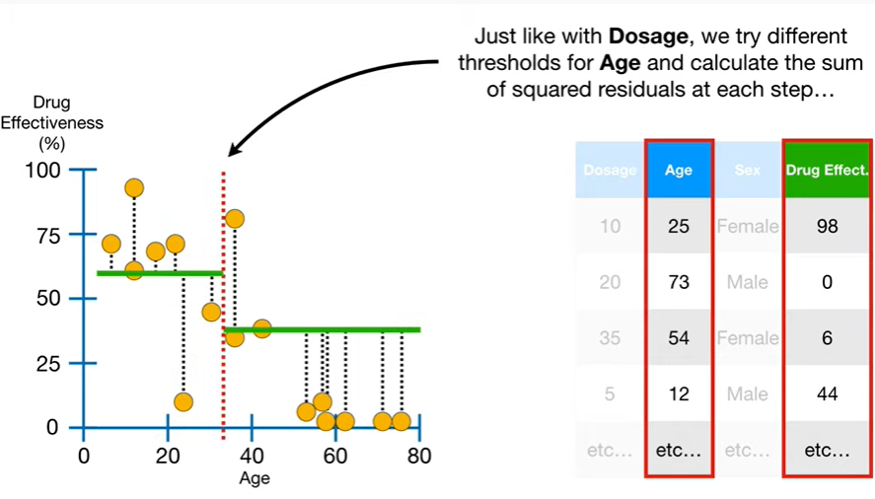

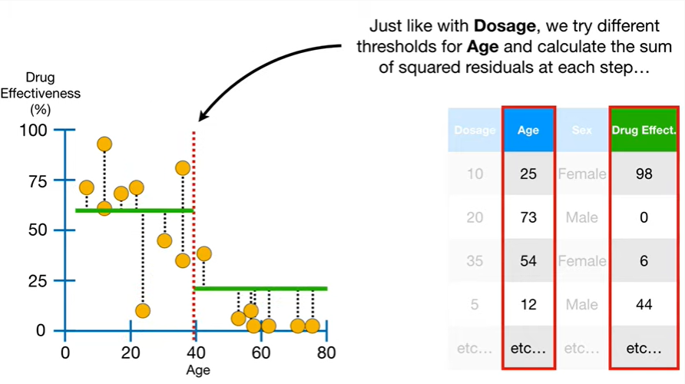

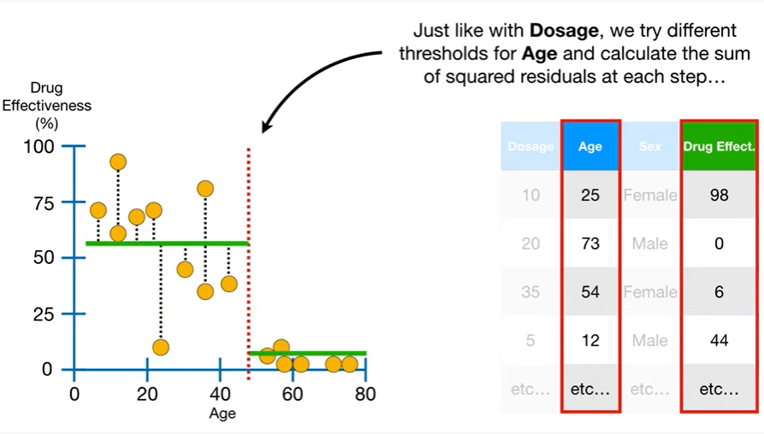

Just like with dosage we tried different thresholds for age and calculate the sum of squared residuals at each step

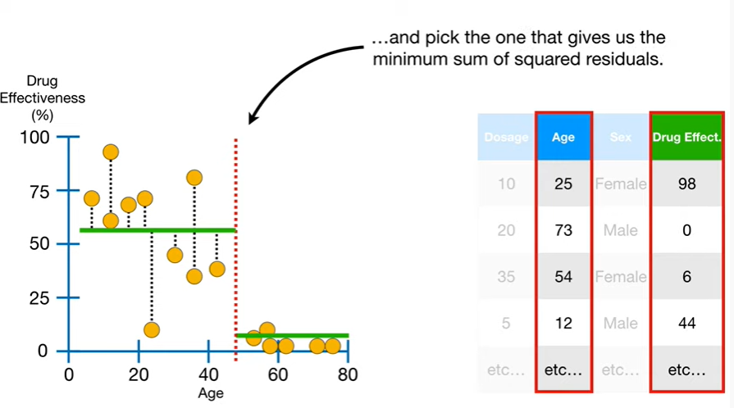

and pick the one that gives us the minimum sum of squared residuals.

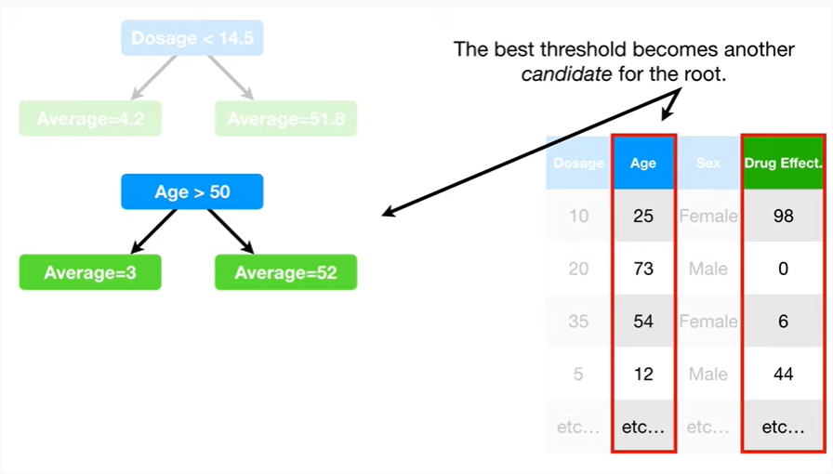

The best threshold becomes another candidate for the root.

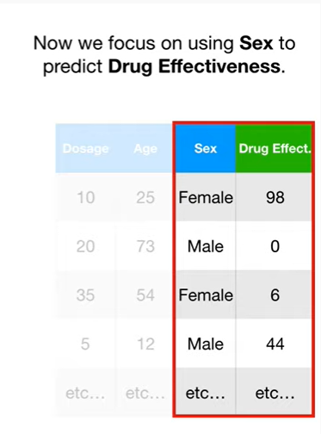

Now we focus on using sex to predict drug effectiveness.

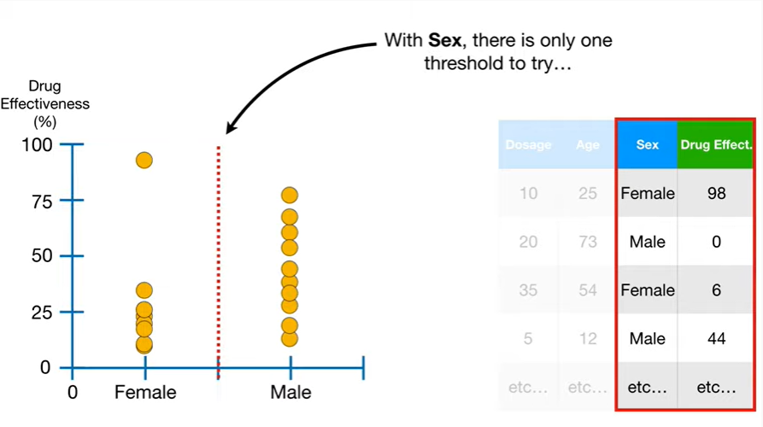

With sex there is only one threshold to try

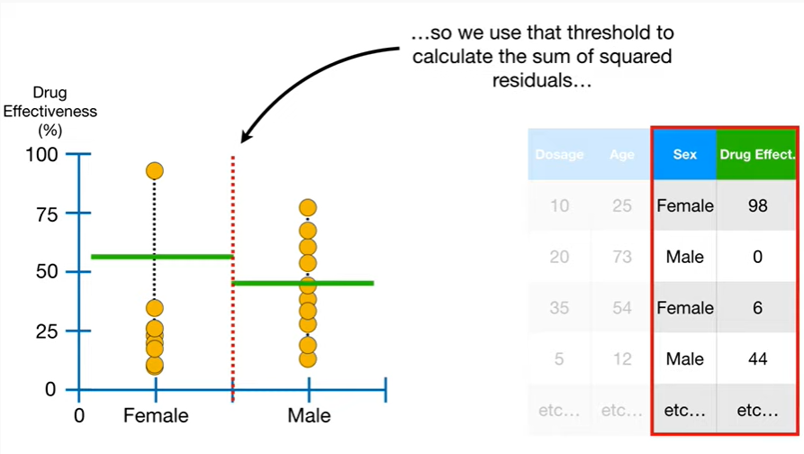

so we use that threshold to calculate the sum of squared residuals

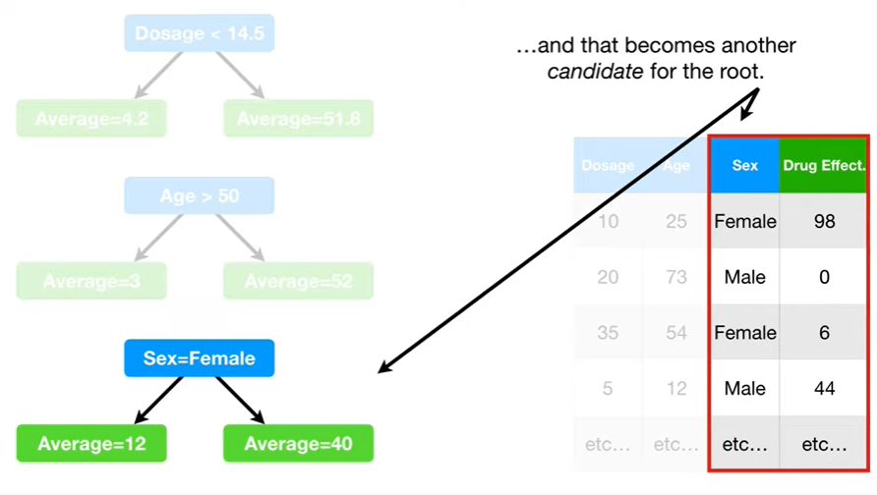

and that becomes another candidate for the root.

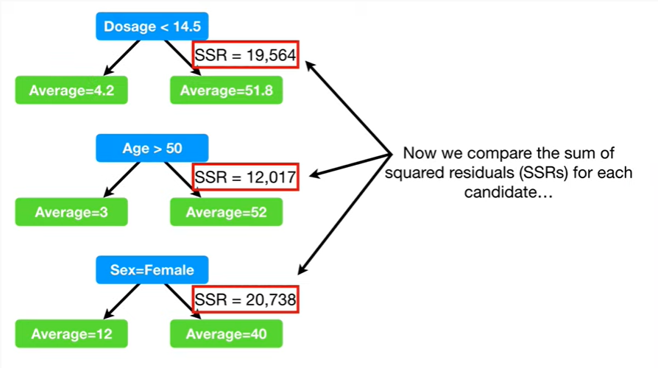

Now we compare the sum of squared residuals SSRS for each candidate

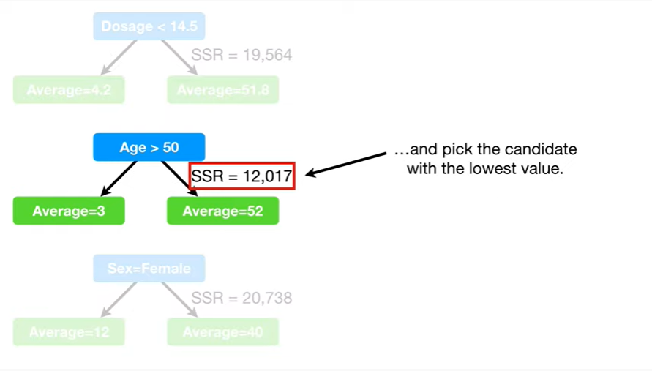

and pick the candidate with the lowest value.

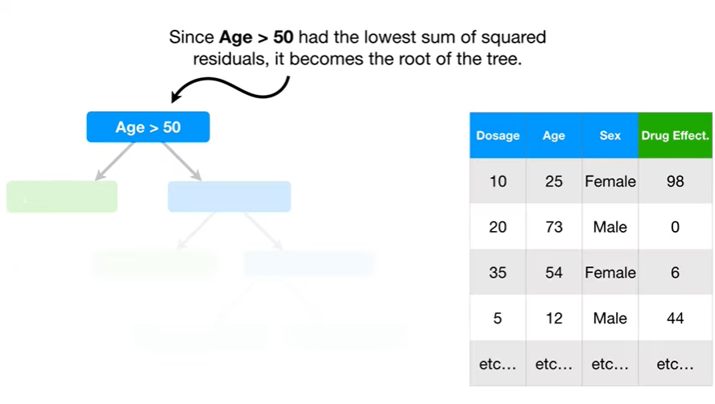

Since age greater than 50 had the lowest sum of squared residuals, it becomes the root of the tree.

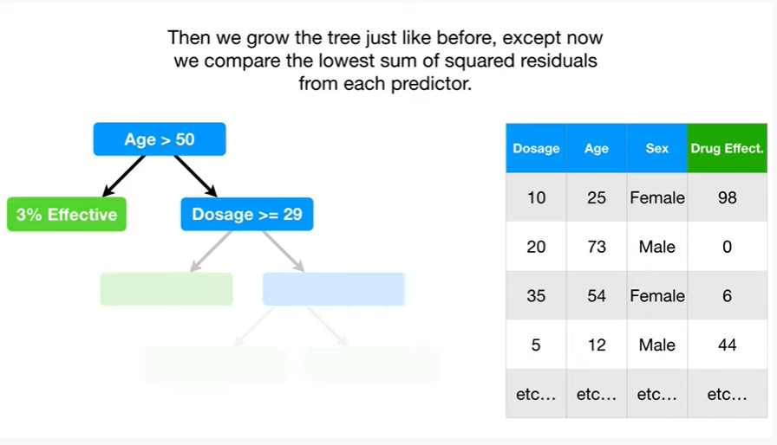

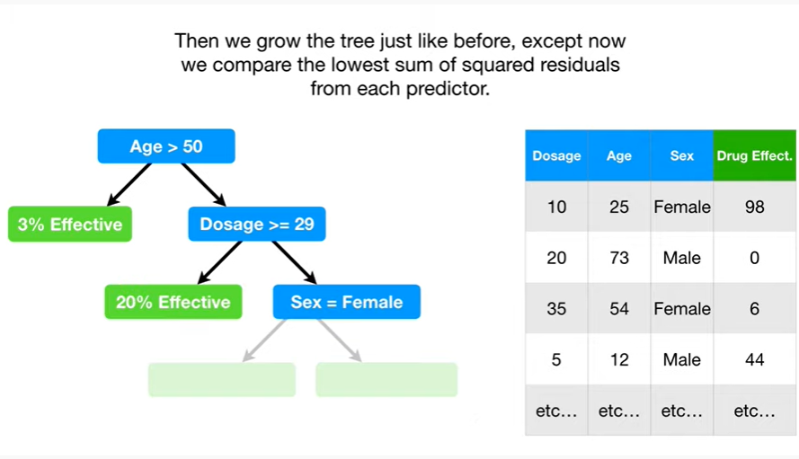

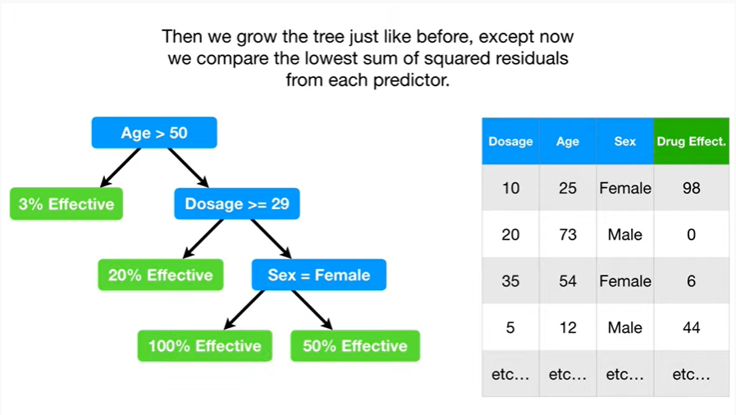

Then we grow the tree just like before except now we compare the lowest sum of squared residuals from each predictor.

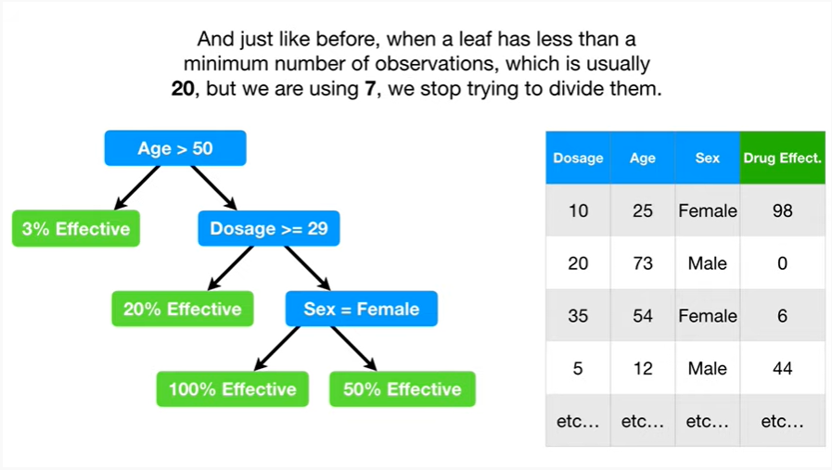

And just like before, when a leaf has less than a minimum number of observations, which is usually 20, but we are using 7, we stop trying to divide them.

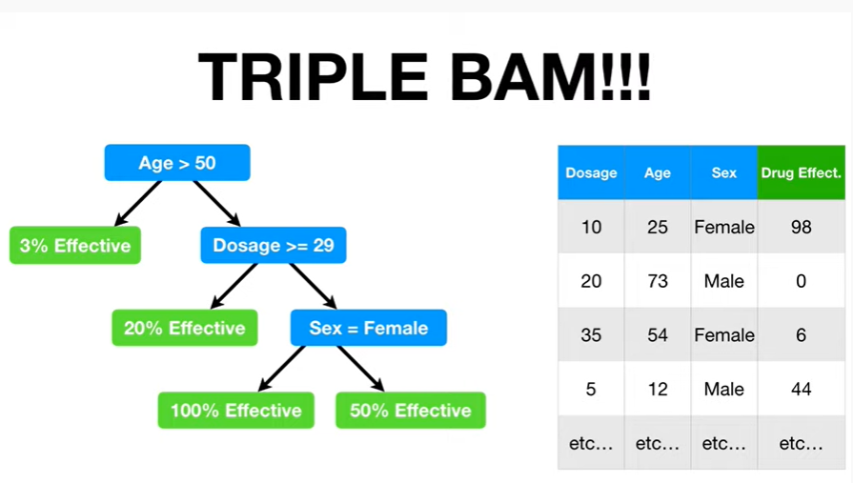

Triple BAM !!!



In summary :

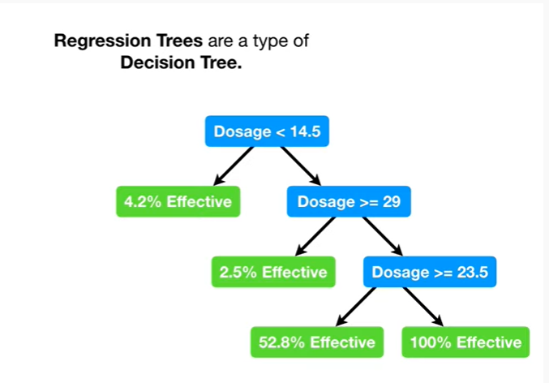

Regression trees are a type of decision tree.

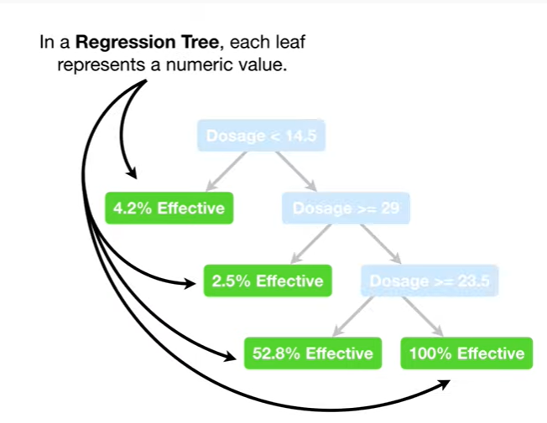

In a regression tree each leaf represents a numeric value.

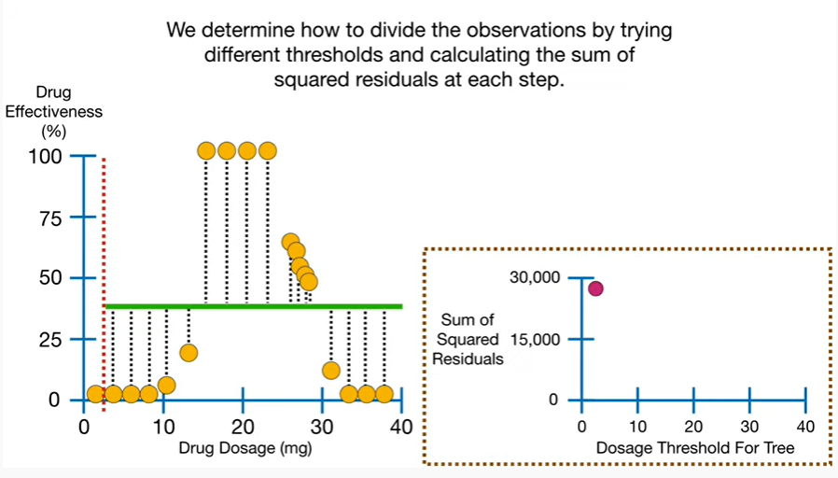

We determine how to divide the observations by trying different thresholds in calculating the sum of squared residuals at each step.

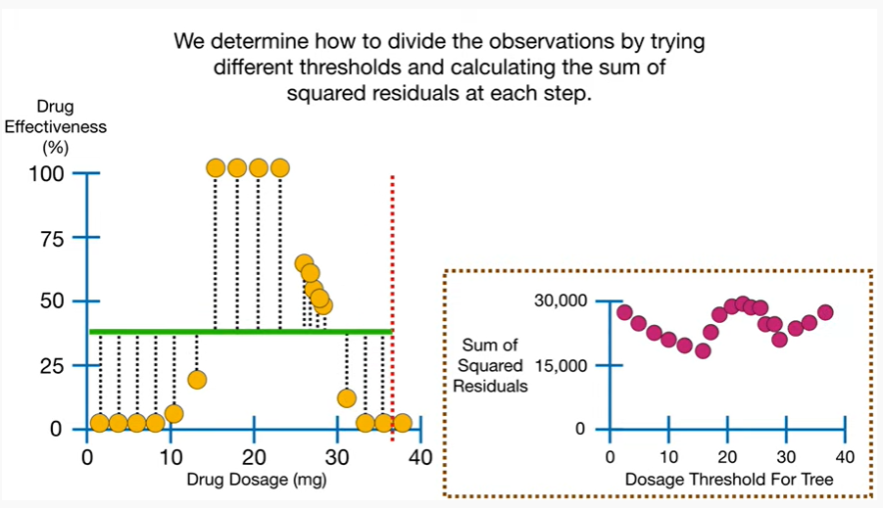

pp boo boo beep beep boo boo peepee poo-poo.

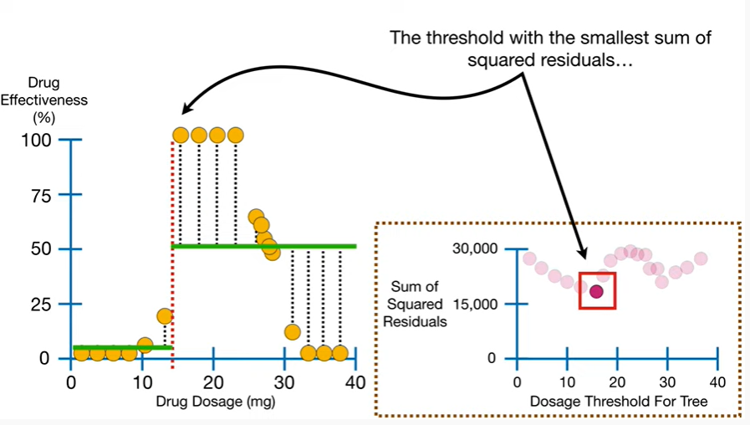

The threshold with the smallest sum of squared residuals

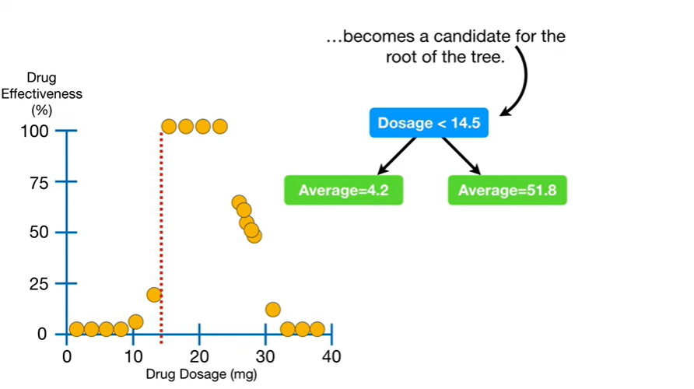

becomes a candidate for the root of the tree.

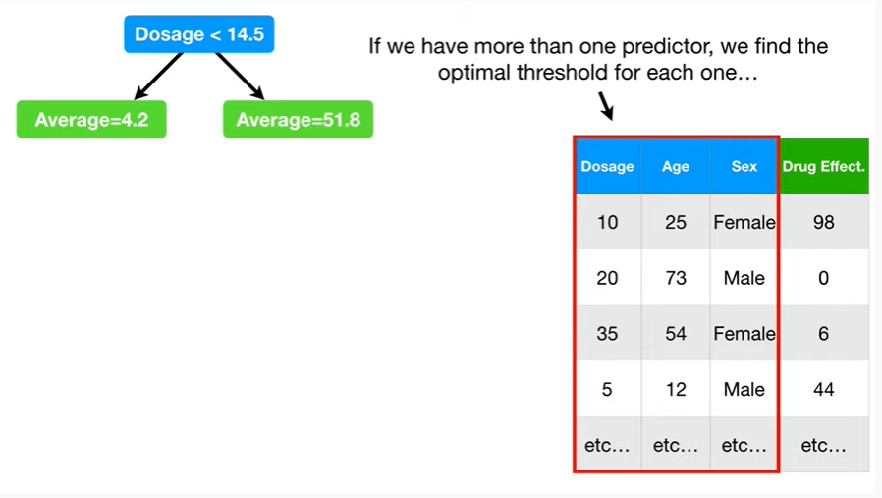

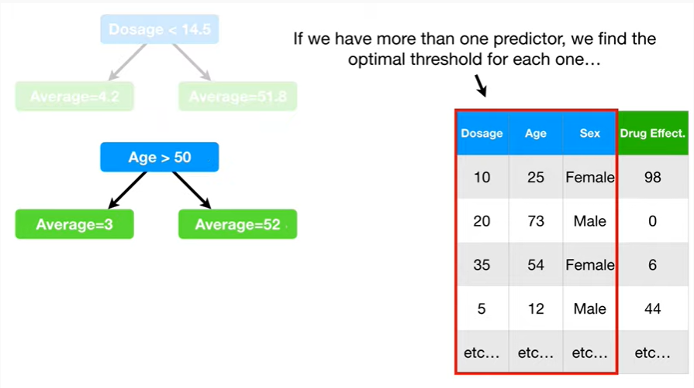

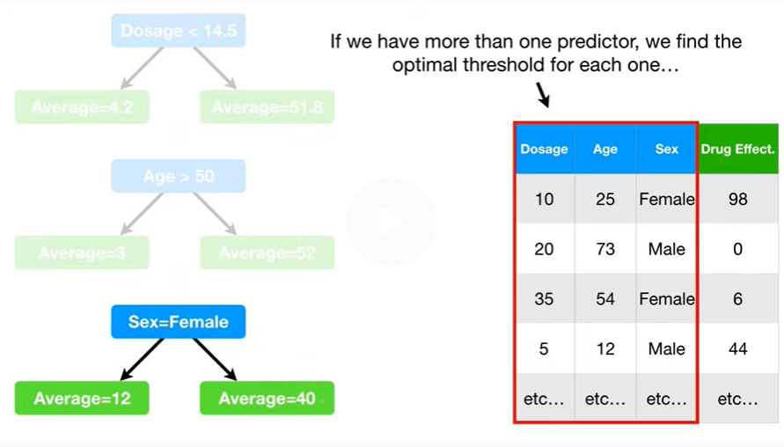

If we have more than one predictor we find the optimal threshold for each one

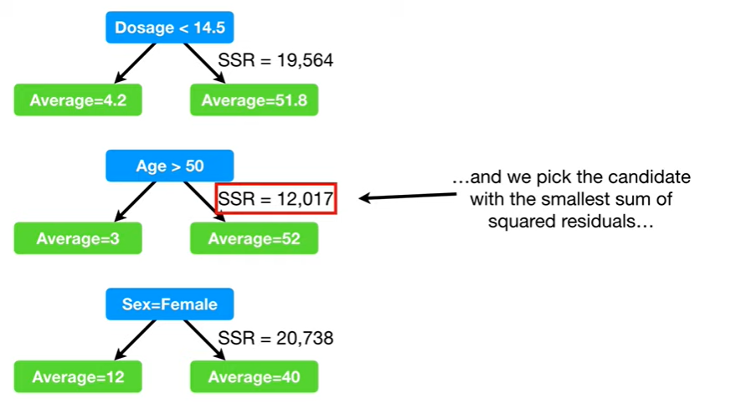

and pick the candidate with the smallest sum of squared residuals

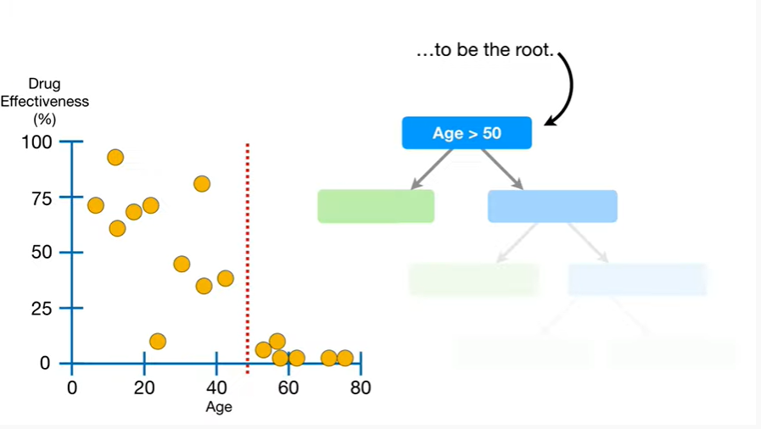

to be the root.

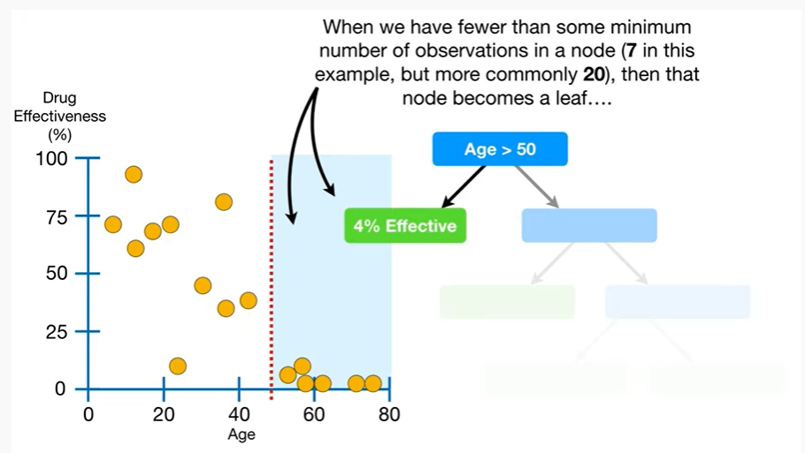

When we have fewer than some minimum number of observations in a node (7 in this example, but more commonly 20), then that node becomes a leaf

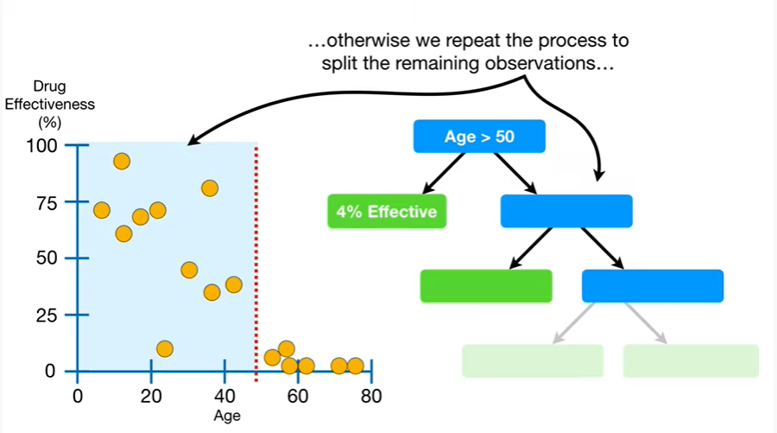

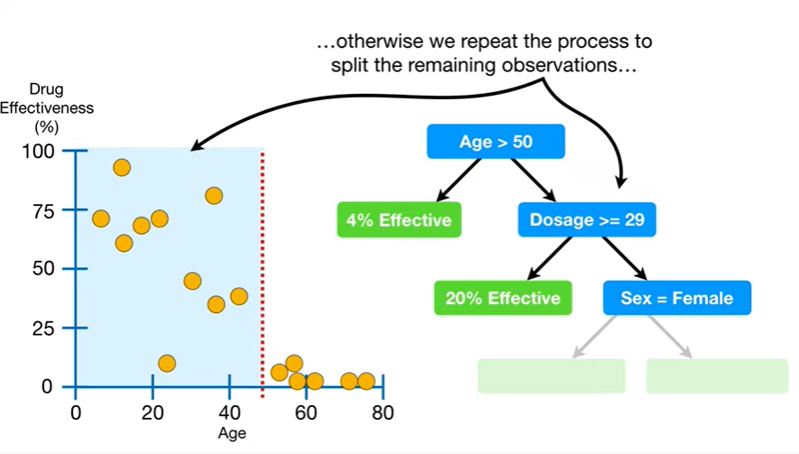

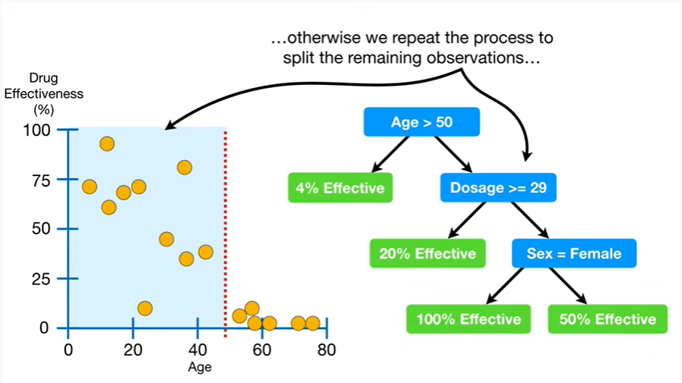

otherwise we repeat the process to split the remaining observations

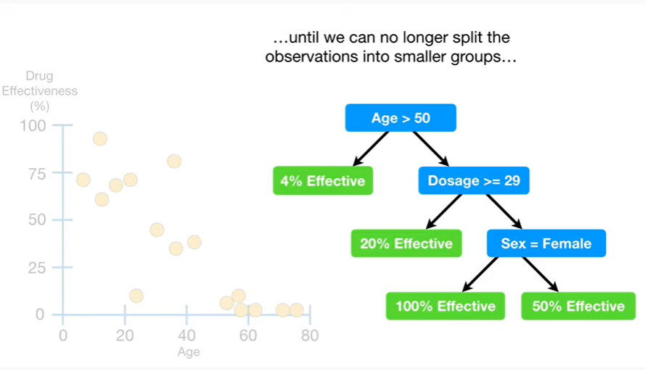

until we can no longer split the observations into smaller groups

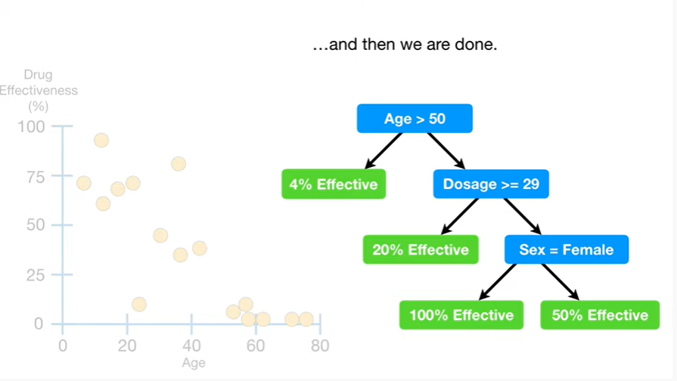

and then we are done.